Short and Long Term Predictions of Emergency Department Patient Resources in the Irish Health Sector



Name: Rohan Paravasthu
Department: Business and Financial Services
Supervisor: Dr. David Leonard
Submitted On: 30 August 2026

This research project is submitted in partial fulfilment of the Degree of Master of Science in Data Analytics at Technological University of the Shannon: Midlands Midwest

Declaration
I have completed the project “Short and Long Term Predictions of Emergency Department Patient Resources in the Irish Health Sector” under my own supervision and for academic/research purposes. The analysis, interpretation, data processing and conclusions in this project have been prepared on the basis of the available data on trolley waiting times in HSE Ireland for the period 1990 to 2017 and suitably analytical approaches.
I declare that the information and results contained in this study rely on the data and method of analysis used in the study. All sources, datasets and published information used have been correctly identified. Findings and conclusions are presented objectively and aimed at offering insights into the nature and effect of trolley waiting times in Ireland.

Student ID Number: K00327946
Name of Candidate: Rohan Paravasthu
Signature of Candidate: Rohan Paravasthu
Date: 30-08-2026

Acknowledgement
Thanks to Dr. David Leonard who assisted me on this project on “Short and Long Term Predictions of Emergency Department Patient Resources in the Irish Health Sector”.
This analysis relies on relevant healthcare data made available by the Health Service Executive (HSE) Ireland and for this reason I am particularly grateful to HSE Ireland. My teachers, mentors and colleagues were very helpful in guiding and supporting me during the project.
Last but not least, I would like to express my gratitude to all who have helped in this study directly or indirectly. They helped us with this analysis and presentation of the results in a good way.

Table of Contents
Declaration 2
Acknowledgement 3
Table of Figures 7
Table of Tables 8
List of Abbreviations 9
Abstract 10
Chapter 1: Introduction 11
Background and Context 11
Problem Statement 11
1.3 Research Objectives 12
1.4 Research Questions 12
1.5 Significance of the Study 13
1.6 Scope and Limitations 13
1.7 Thesis Structure 14
Chapter 2: Literature Review 15
2.1 Introduction 15
2.2 HSE Ireland: Impact of the Trolley Waiting Time Crisis 15
2.2.1 Background of the Trolley Reporting System 15
2.2.2 The Scale of the Crisis and Its History 15
2.2.3 The Drivers of the Crisis and the Broader Health System 16
2.2.4 Measurement Indicators and Their Meaning 16
2.2.5 Regional and National Patterns 16
2.2.6 Relevance to the Present Research 17
2.3 Methods of Forecasting Time Series Data 17
2.3.1 Traditional Statistical Methods 17
2.3.2 Modern Machine Learning Approaches 18
2.3.3 Simulation and Operational Research Approaches 19
2.3.4 Selection of Measures of Accuracy 19
2.4 Previous Studies on Forecasting the Number of A&E and Hospital Attendances 20
2.4.1 The Base Study 20
2.4.2 Systematic Reviews of Prediction Models 20
2.4.3 Comparative Studies of Multiple Forecasting Methods 21
2.4.4 Results of the Studies on Crowding, Surge and Outcomes 21
2.4.5 Hospital Demand Forecasting on a Broader Scale 21
2.4.6 Summary of the Findings from the Various Studies 22
2.4.7 Data Granularity Across Studies 22
2.4.8 Geographic Spread of Existing Research 22
2.5 Discussion: How Existing Research Shapes the Proposed Research 23
Chapter 3: Methodology 25
3.1 Research Design 25
3.2 Data Collection 26
3.3 Data Preprocessing 27
3.4 Model Specification 28
3.5 Model Training & Validation 31
3.6 Acceptable Model Error Based on Literature 31
3.7 Model Evaluation Metrics 32
Chapter 4: Analysis and Findings 34
4.1 Introduction 34
4.2 Exploratory Data Analysis 34
4.3 Daily Forecasting Experiment (RQ1) 38
4.4 Weekly Forecasting Experiment 41
4.5 Monthly Forecasting Experiment 42
4.6 Comparison Across Granularities (RQ2) 44
4.7 Feature Importance and Practical Implications (RQ3) 45
4.8 Summary of Findings 45
Chapter 5: Discussion 47
5.1 Overview of Key Findings 47
5.2 Comparison with the Base Study and Related Literature 47
5.3 Interrogating the AutoML-Selected Model 48
5.4 Practical Implications for Hospital Capacity Planning 49
5.5 Limitations of the Study 49
5.6 Suggestions for Future Work 50
Chapter 6: Conclusions and Recommendations 51
6.1 Summary of the Study 51
6.2 Key Conclusions 51
6.3 Contributions of the Study 52
6.4 Recommendations for Practice 52
6.5 Recommendations for Future Research 52
6.6 Final Remarks 53
References 54

Table of Figures
Figure 1 Job overview panel for the daily AutoML experiment (experiment1_daily), Azure Machine Learning Studio. 30
Figure 2 Model summary panel for the daily experiment, showing the winning algorithm, normalized RMSE and sampling rate. 30
Figure 3 Trolleys – daily trend, 1 January 2024 to 31 May 2026. 36
Figure 4 Distribution of ED Trolleys by day of week. 36
Figure 5 Surge Capacity in Use versus Total Trolleys. 37
Figure 6 Distribution of ED Trolleys, 1 January 2024 to 31 May 2026. 38
Figure 7 Average ED Trolleys by calendar month, 1 January 2024 to 31 May 2026. 39
Figure 8 Relationship between ED Trolleys and Ward Trolleys. 39
Figure 9 Daily experiment leaderboard, ranked by normalized RMSE (experiment1_daily). 40
Figure 10 Daily experiment – forecast versus actual, selected validation fold. 40
Figure 11 Daily experiment – residuals histogram. 41
Figure 12 Weekly experiment leaderboard, ranked by normalized RMSE (experiment2_weekly_v2). 43
Figure 13 Weekly experiment – forecast versus actual, selected validation fold. 43
Figure 14 Weekly experiment – residuals histogram. 44
Figure 15 Monthly experiment leaderboard, ranked by normalized RMSE (experiment3_monthly). 44
Figure 16 Monthly experiment – forecast versus actual, selected validation fold. 45
Figure 17 Monthly experiment – residuals histogram. 46
Figure 18 Evaluation metrics returned by Azure AutoML across the three forecasting granularities. 46

Table of Tables
Table 1 Configuration common to, and distinct between, the three Azure AutoML experiments. 30
Table 2 Benchmark MAPE and model rankings from Jilani et al. (2019). 32
Table 3 Performance of the best AutoML model across forecasting granularities. 33
Table 4 Supplementary rolling-origin cross-validation of a comparable gradient-boosted model, five sequential folds, daily granularity. 41

List of Abbreviations
List of Abbreviations
Abbreviation | Full Term
AI | Artificial Intelligence
ANN | Artificial Neural Network
ARIMA | Autoregressive Integrated Moving Average
AutoML | Automated Machine Learning
ED | Emergency Department
FTS | Fuzzy Time Series
HSE | Health Service Executive
MAE | Mean Absolute Error
MAPE | Mean Absolute Percentage Error
ML | Machine Learning
RMSE | Root Mean Squared Error
R² | Coefficient of Determination
RQ | Research Question
SARIMA | Seasonal Autoregressive Integrated Moving Average
TWT | Trolley Waiting Time
UK | United Kingdom

Abstract
Overcrowding in the waiting room of a trolley in a hospital and the waiting time in emergency departments are still significant issues in the Irish healthcare system. The aim of this study is to explore the potential for Microsoft Azure Automated Machine Learning (AutoML) to predict the number of patients on Emergency Department (ED) trolleys based on published data on trolleys waiting times by HSE Ireland. The study fills a gap in the literature, as the majority of forecasting studies have targeted either emergency department attendance or admissions, rather than specifically the number of trolleys in the ED.
A secondary HSE data source from 1 January 2024 to 31 May 2026 is used in the study. Azure AutoML was used to create three forecasting experiments: one at daily level, one at weekly level and one at monthly level. The experiments tested ED Trolleys as the target variable with pressure indicators from healthcare and calendar features as the predictors. The performance of the models was assessed in term of Mean Absolute Error (MAE), Root Mean Squared Error (RMSE), Mean Absolute Percentage Error (MAPE) and R².
The Voting Ensemble algorithm has been chosen as the best performing algorithm for all three forecasting granularities. The daily model achieved an MAE of 23.63, RMSE of 28.30, MAPE of 15.08% and R² of 0.758. The weekly model achieved an MAE of 110.47, RMSE of 133.41, MAPE of 7.37% and R² of 0.207, while the monthly model achieved an MAE of 175.48, RMSE of 195.81, MAPE of 3.44% and R² of 0.139. The monthly model was less reliable because it had fewer observations, but MAPE decreased with an increasing forecasting period.
The results show that the most feasible finding between the accuracy of the forecast, sample size and stability is weekly forecasting. The analysis also showed that reliability was lower outside of the usual holiday season, indicating the need to combine automated forecasts with the operational knowledge and associated measures of healthcare pressures. As a whole, this study shows that Azure AutoML can offer valuable predictions of the HSE trolley numbers, yet reveals vital restrictions that need to be dealt with before it is put into practice in an operational setting.

Chapter 1: Introduction

1.1 Background and Context
Overcrowding at the emergency department (ED) and the resulting practice of lying on trolleys waiting for a hospital bed is one of the most vocal and visible issues faced by the Irish health system. Based on this Trolley Watch series the Health Service Executive (HSE) has published a daily count of patients waiting on trolleys since 2006, and over the past 15 years, despite a series of policy interventions, the numbers on trolleys have continued to rise. Overcrowding of trolleys is not just about the comfort of the patients, but is linked to increased length of hospital stay, greater risk of adverse clinical outcomes and a heavy burden on nursing and medical staff and continues to be one of the top indicators of the health system performance in Ireland.
Alongside the growth of this crisis, the healthcare sector internationally has seen rapid growth in the application of machine learning to demand forecasting. Time-series forecasting techniques, ranging from classical statistical methods such as ARIMA to modern ensemble and gradient-boosting algorithms, have been applied to predict emergency department attendances, hospital admissions, and bed occupancy in a number of health systems, most notably in the UK study by Jilani et al. (2019), which forecast ED attendance across four hospitals using a comparison of several forecasting algorithms. What is comparatively rare in this literature, as the review in Chapter 2 sets out in detail, is a study that forecasts trolley waiting numbers specifically, as opposed to the broader and less operationally specific measure of attendance or admission.
This thesis sits at the intersection of these two developments. It applies Azure Machine Learning's Automated ML (AutoML) service, a cloud-based platform that automatically trains, cross-validates and ranks a wide range of candidate forecasting algorithms, to the HSE's own published trolley waiting data, in order to establish how accurately, and at what level of temporal detail, this kind of automated approach can forecast ED trolley numbers in an Irish acute hospital setting.

1.2 Problem Statement
While the trolley crisis in Ireland is large and longstanding, and while there has been increasing interest in using machine learning for hospital demand prediction internationally, there is relatively limited published work which directly applies modern forecasting methods to the Irish trolley waiting data. Existing international studies, such as the base study by Jilani et al. (2019), which this thesis most closely relied on, typically predict attendance or admission numbers and not the trolley count itself which is most closely related to daily operational decision making and public reporting in the Irish context.
The second, more practical, problem that motivates this study is to allow students to use the information they learned in real-world applications of the course. Considering the HSE trolley data, it is published at daily, weekly, and monthly levels of aggregation, however, it is not known a priori which of these would be useful for the basis of forecasting. Relative forecasting error tends to fall as aggregation level becomes coarser, because averaging tends to smooth out daily volatility; however, aggregation also drastically cuts down on the number of training records for a model, which can compensate for the improvement in relative forecasting error. If there is no like-for-like comparison at the granularities, the hospital planner and researcher is left with nothing but little to choose from which granularity to believe.
Lastly, products like Azure AutoML reduce a technical hurdle for creating a forecasting model significantly, by streamlining much of the algorithm selection and tuning process that might otherwise demand specialist expertise. But this automation can also make it harder to know exactly what a selected model can and can't be relied upon to do, especially on edge cases like holiday times, and about the consistency of accuracy of an automatically selected model during each validation. The current thesis is motivated by these three problems: There is no existing research on trolley forecasting in an Irish context; There is no certainty around which data granularity to trust; There is no research that interrogates and does not just take an AutoML-selected model at face value.

1.3 Research Objectives
This thesis aims to provide a measure of the accuracy of Azure AutoML's prediction of the number of HSE ED trolleys and to determine practical situations in which that prediction can be relied upon. Specific objectives are to:
- Build and format a working HSE trolley data set that can be aggregated on a daily, weekly and monthly level and can be used for automated machine learning.
- For each of the three granularities, set up and execute autonomous Azure AutoML forecasting experiments on the target variable: ED Trolleys.
- Assess the accuracy of the models developed based on a common set of accuracy measures (MAE, RMSE, MAPE and R²) and compare them with the closest possible models that have been published in the literature.
- Discuss the comparison of accuracy and reliability of forecast at the three granularities and determine which is the most useful practically for hospital capacity planning.
- Review the practical constraints of the AutoML selected model, and how it performs at other times of the year when demand is different due to holidays.

1.4 Research Questions
In this study the following research questions are asked:
RQ1: What is the accuracy of the prediction of the number of patients on ED trolleys in HSE Trolley Watch data made by Azure Automated Machine Learning (AutoML)?
Here, we run three independent AutoML forecasting experiments corresponding to each level of data granularity and compare forecasters with standard regression accuracy metrics with the best available benchmark from the published literature: the UK-based study by Jilani et al. (2019).
RQ2: What is the effect on the accuracy and reliability of the forecasts if the data is aggregated at daily, weekly or month level?
To get at this question, the same underlying AutoML process is run at each of the three granularities and the metrics generated are compared directly, without taking at one level of aggregation as self-evidently better than another.
RQ3: What are some of the practical limitations that impact the use of an AutoML-selected ensemble model in real hospital capacity planning?
This question takes a step away from the numbers in the headline and asks some questions about how consistent the winning model's performance was across the various periods of validation, how it may have performed in unusual demand periods (e.g. holiday periods) and what the implications are for a manager of a hospital who might want to adopt this model in practice.

1.5 Significance of the Study
This thesis makes a contribution in three respects. Empirically it removes the need to perform a forecasting step on a measure of real public and operational significance in Ireland, the waiting times of HSE trollies, and compares temporal granularities (daily, weekly and monthly) not previously found in the literature surveyed in Chapter 2. Methodologically, it’s not treating an AutoML-chosen model as a final product, but rather the starting point for interrogation, checking out other models on the leader board, fold-level consistency and known traits of reporting from the Azure platform itself.
From a practical standpoint, the results have a clear implication for hospital administrators and health system planners in terms of deployment of an automated forecasting system like this. Granularity comparison is the central theme of this study and it provides a more nuanced, decision-relevant answer to the question of whether automated forecasting works, or not, than a single number does: which level of aggregation achieves forecast accuracy and provides the planner with a practical stability before taking action on a forecast. The existing literature on ED and trolley demand forecasting is almost entirely limited to reporting performance of a single model at a single granularity; thus, this type of comparative evidence focused on decisions is largely missing.

1.6 Scope and Limitations
This study only uses Trolley Watch data reported at the HSE level, and available only from 1 January 2024 – 31 May 2026, and does not involve patient-level clinical data. The 24 hour waiting figures, Ward Trolleys and Surge Capacity in use are used as predictors but not as additional outcomes of their own; ED trolley is modelled as the sole outcome variable across all three experiments.
The focus of the study is further limited to the Azure Machine Learning AutoML service, and not a hand crafted comparison of individually tuned algorithms, which is the frame in which the research questions are presented, but which also implies that the scope of the possible conclusions is limited to the implementation of AutoML provided by Azure, and not the potential upper limit of what can be achieved with any possible forecasting approach. Likewise, the monthly experiment is based on just 29 records and the results of this experiment should be interpreted with this constraint in mind throughout Chapters 4 and 5.

1.7 Thesis Structure
This thesis is organised into six chapters:
- Chapter 1: Introduction. Establishes the background, problem, objectives, research questions and scope of the study.
- Chapter 2: Literature Review. Reviews the HSE trolley crisis, forecasting methods for time-series and hospital demand data, and the base study by Jilani et al. (2019).
- Chapter 3: Methodology. Describes the data, the Azure AutoML configuration, and the model training, validation and evaluation approach.
- Chapter 4: Analysis and Findings. Presents the exploratory data analysis and the results of the three AutoML forecasting experiments.
- Chapter 5: Discussion. Interprets findings and compares with literature, discusses limitations of the study and implications and future studies.
- Chapter 6: Conclusions and Recommendations. Summarizes the study's findings in answer to the three research questions and provides recommendations for practice and future study.

Chapter 2: Literature Review

2.1 Introduction
This chapter reviews the published literature on HSE Ireland's Trolley Waiting Time (TWT) crisis, as well as the forecasting of hospital emergency department (ED) demand. This chapter can be divided into several sections. The effects of the Trolley Waiting Time crisis in Ireland are discussed in section 2.2. Forecasting time series is explained in 2.3, beginning with standard statistical techniques and ending with modern machine learning techniques. Existing research studies that have predicted the number of people attending the emergency department and hospital are reviewed in section 2.4, along with their datasets, experiments and results. The existing research and how it influences the current research project is discussed in section 2.5. All factual statements have been documented by the use of a reference from the reference list supplied for this thesis.

2.2 HSE Ireland: Impact of the Trolley Waiting Time Crisis

2.2.1 Background of the Trolley Reporting System
The Urgent and Emergency Care Report (HSE.ie, n.d.) is a daily report published by the Health Service Executive in Ireland and is a formerly known as TrolleyGAR. This report documents the number of patients who end up on trolleys or other inadequate beds in the emergency departments and hospital wards of the country. A weekly version of this report is also published separately (HSE.ie, 2019). The report monitors a number of key indicators. These include the number of trolleys patients are on, patients waiting over 24 hours (with a focus on patients over 75 years old), the number of delayed transfers of care and the extent of surge capacity use in each hospital (HSE.ie, n.d.). This daily reporting system is the basis for the dataset in this research project.

2.2.2 The Scale of the Crisis and Its History
The trolley crisis in Ireland is not a new problem. In 2018, the Irish Medical Organisation published a position paper about the challenges of attaining a 6 hour target for emergency department attendances, which at this time was already a serious national issue (IMO, 2018). Lynch et al. (2019) investigated the impact on regional trolley counts of reconfiguration of emergency departments in four regions in Ireland from 2005 to 2015. The study found that in three of the four regions studied, there was a significant change in trolley numbers in the twelve months following reconfiguration of services (Lynch et al., 2019). This is a demonstration of a measurable impact of structural change on the number of trolleys, and that trolley waiting data can be analysed using formal time series methods and not viewed as random/uncertain.
The crisis has been covered by news in the years that have followed these studies. As the country started to emerge from public health restrictions during the pandemic, the Health Service Executive (HSE) warned of longer waiting times in emergency departments (EDs) (Cullen 2021). Emergency department staffing was reported as being a problem in recent times too, with O'Regan (2025) reporting that patients were being forced to wait in ambulances due to the lack of trolleys at emergency departments. In combination with Lynch et al.'s (2019) academic analysis, these reports show that the trolley crisis in Ireland is by no means a short term or occasional occurrence, but rather a long-standing and persistent issue.

2.2.3 The Drivers of the Crisis and the Broader Health System
The trolley situation cannot be divorced from the overall pressures being faced by the Irish health system. The work of Burke et al. (2021) explored the response of the Irish health system to the shock of the COVID-19 pandemic, and the need for policy change to make the health system more resilient in future. This points to the overall issues of health system capacity and planning in Ireland rather than just to acute changes in the number of patients presenting to the emergency department. Cummins et al. (2022) conducted an Ireland-wide cross sectional, multi-centre census of various hospitals to assess the factors that affect the attendance of patients in emergency departments. This census based approach captured detailed data directly from patients in EDs and revealed that there are many factors other than beds which impact on the numbers of patients presenting to EDs in the first place (Cummins et al., 2022). This research, alongside Health Information and Quality Authority (HSE Mid West) data analysis of urgent and emergency healthcare services in the HSE Mid West (Health Information and Quality Authority, n.d.), indicates that the trolley crisis is caused by a combination of demand side factors (why, when and how patients attended) and supply side factors (number of beds; delayed discharges).

2.2.4 Measurement Indicators and Their Meaning
All the indicators measured in the HSE reporting system have a unique significance for hospital planning. The number of patients on trolleys is an indicator of the "snapshot" of the emergency department at the time of measurement (HSE.ie, n.d.). The number of patients waiting over 24 hours represents more severe and lengthy pressure and within this, particular focus is given to patients aged 75 years and over as these are considered to be more susceptible to the adverse impact of long waits (HSE.ie, n.d.). Delayed transfers of care are a different aspect of the issue, as the patient is medically fit to leave hospital but can't as a home care package or a step down bed is not available (HSE.ie, n.d.; Health Information and Quality Authority, n.d.). Surge capacity figures indicate how many beds (over and above the normal allocation of beds) have been made available to manage the demand on a particular day (HSE.ie, n.d.). These four indicators together tell not only how many patients are waiting but also why they are waiting, a very important consideration for any forecasting model that is developed using this data set.

2.2.5 Regional and National Patterns
The trolley crisis is not distributed uniformly throughout the country. Lynch et al. (2019) researched four distinct Irish regions – the West, North-East, South and Mid-West - and determined that the impact of emergency department reconfiguration on numbers of trolleys varied across the four regions, with three of the four regions experiencing a significant difference after reconfiguration. This regional variation indicates that whilst a single national forecasting model may not be able to represent each regional pattern equally well, care should be taken with any hospital level or regional level differences that may occur when building a forecasting tool on this data. An excellent example of how one region can be analysed in detail to determine pressures on emergency healthcare services within a single area is the analysis of urgent and emergency healthcare services in the HSE Mid West conducted by the Health Information and Quality Authority (Health Information and Quality Authority, n.d.).

2.2.6 Relevance to the Present Research
Some aspects of this section have a direct relevance to the present thesis. Firstly, the HSE Urgent and Emergency Care Report offers a structured, daily and long time series dataset, which is favourable for forecasting using time series models (HSE.ie, n.d.). Secondly, the current severity and persistence of the crisis, which is evidenced in the academic literature (Lynch et al., 2019), government policy documents (IMO, 2018), quality assurance bodies (Health Information and Quality Authority, n.d.) and in the news (Cullen, 2021; O'Regan, 2025), provides strong practical justification for developing an accurate forecasting tool. Third, the reporting system distinguishes between trolley numbers and delayed transfers of care and surge capacity (HSE.ie, n.d.) which affords the chance to examine a number of related, but distinct, metrics for pressure in a forecasting model, as opposed to relying on a single composite number. Improved trolley forecasts would enable hospital planning decisions, and alleviate the pressures detailed in this literature.

2.3 Methods of Forecasting Time Series Data

2.3.1 Traditional Statistical Methods
In the field of healthcare forecasting research, traditional statistical models are still frequently employed as they are easy to decipher and do not necessarily require voluminous data. Some of the most widely used models for predicting demand for emergency department services are the autoregressive integrated moving average (ARIMA) model, and its seasonal counterpart, the seasonal ARIMA model (SARIMA). The ARIMA models were also one of the primary comparison approaches used by Jilani et al. (2019) in its prediction of hospital emergency department attendances, alongside a fuzzy time series approach, as well as a neural network approach. Rocha and Rodrigues (2021) also examined a variety of statistical methods, such as exponential smoothing and seasonal ARIMA, to predict Emergency Department admissions with ten years of historical data. In their work, AL Yarubi, Kamisan and Norrulashikin (2025) compared the SARIMA model to the Holt Winters exponential smoothing method in forecasting emergency department crowding, illustrating the ongoing testing of traditional statistical models against newer ones in contemporary research.
The exponential smoothing method is the method that assigns greater weight to the recent observations than to the earlier ones and is appreciated for its simplicity and low computational load (Rocha and Rodrigues, 2021; AL Yarubi, Kamisan and Norrulashikin, 2025). In the field of forecast statistical models, probabilistic approaches have been used too. Rostami-Tabar, Browell and Svetunkov (2023) created probabilistic forecasts for the number of patients arriving at emergency departments, and demonstrated that traditional statistical modelling can not only be used to provide a point forecast, but also an interval around the point forecast.
One of the limitations found in this traditional literature is that classical statistical models make certain assumptions about the data, including assumptions of stationarity, which are often violated by emergency department data due to weekday patterns, seasonal effects and holiday effects (Jilani et al., 2019). This limitation has spurred research into other methods, such as a fuzzy time series (FTS) method proposed by Jilani et al. (2019) that aims to minimize the use of rigorous statistical assumptions and still provide high-quality short-term and long-term predictions.
The fuzzy time series method deserves special attention since it does not belong entirely to the traditional time series statistical family as well as to the modern machine learning family. Jilani et al., (2019) developed a Heuristic Based Fuzzy Time Series model which clusters historical data in fuzzy sets instead of considering each data as a point value, hence it takes care of uncertainty and imprecision in time series data without requiring the precise assumptions as done by ARIMA. Jilani et al., (2019) tested this method on the data obtained from four different hospitals and compared its performance with ARIMA and neural network models on the same data, and through the Harvey, Leybourne and Newbold test it was established that the superiority was not due to chance but a statistical significance. The relative simplicity of the method in terms of computation and the lack of the need for complex statistical assumptions also led Jilani et al. (2019) to suggest its ease of use in practice for any hospital manager looking to apply it in real world hospital scenarios.

2.3.2 Modern Machine Learning Approaches
The recent published literature in emergency department forecasting has shifted towards employing machine learning techniques in addition to classical statistical models. In general, these methods are more apt in addressing non-linearities in the data, and can leverage a greater number of input variables.
In this research field, gradient boosted tree methods have been particularly popular. One of the most recent studies, is Extreme Gradient Boosting or XGBoost. Huang, Hardin and Prakash (2025) used XGBoost with temporal and seasonal feature engineering to predict the number of patients arriving at the ER in various hospitals, and compared its performance in different hospital settings. Zhou et al. (2025) applied a gradient boosted method to predict hospital outpatient volume, showing that these methods are inserted in a wide variety of hospital demand forecasting, not just ED attendance. Nevanlinna et al. (2025) applied the more efficient gradient boosting algorithm, LightGBM, to time series data for predicting emergency department crowding-related mortality outcomes, demonstrating how gradient boosting algorithms can be applied to outcomes directly linked to patient safety beyond the simple attendance counts.
There have been other studies that have compared several machine learning algorithms to each other in a single study. Porto and Fogliatto (2024) evaluated different machine learning methods with varying degrees of feature engineering to predict patient arrivals in EDs and obtained satisfactory results for all the models tested. An explainable machine learning approach developed by Peláez-Rodríguez et al. (2024) focused on multi-model regression and continuous training to predict hospital emergency department visits, emphasising the capacity of hospital staff to comprehend the rationale behind the model's prediction, not just viewing it as a black box. Tuominen et al. (2024) predicts ED utilization with high performance machine learning models that take in several input parameters, again demonstrating that a combination of different types of information can enhance the predictive power of the model.
Machine learning has also been combined with more traditional forecasting techniques in hybrid approaches. Zhao (2026) presented a hybrid time series and machine learning method for the demand forecasting and capacity assessment in the emergency care system, based on the Beijing evidence, which shows that hybrid method of classical time series decomposition and machine learning correction can enhance the demand forecasting results. Lim et al. (2024) adopted a similar but slightly different strategy, identifying and predicting a surge in ED demand, not just a surge in actual numbers of ED arrivals. Gafni-Pappas and Khan (2023) directly assessed the performance of machine learning models versus more traditional prediction methods for predicting ED attendance per day, and found that machine learning could improve the accuracy of predictions.
Rampengan, Permana and Wuisan (2025) examined the applications of machine learning in hospital bed management and patient flow in general. This review is valuable as it sets the EDP forecasting in the broader context of hospital resource management, such as staffing and bed planning, and is closely related to the types of decisions that accurate trolley forecasting could inform.

2.3.3 Simulation and Operational Research Approaches
Not every research in this field is directly related to forecasting with statistical or machine learning methods. Other studies employ simulation or operational research methods to help to develop an understanding and enhance the performance of the emergency department. There are other simulation approaches that attempt to assist decision-makers in balancing several competing measures of performance for an emergency department, as has been done by Abo-Hamad and Arisha (2012) in an Irish hospital. Rashwan (2017) created a combined model for staffing and shift scheduling for hospitals, this being more of a staffing problem than a problem of attendance forecasting per se, but similar because forecasting attendance numbers is normally needed before staffing decisions can be made effectively. As illustrated in these studies, forecasting research is not a standalone activity. Rather it is linked to a larger series of tools used in conjunction by hospital managers to plan and manage ED capacity such as simulation and scheduling.

2.3.4 Selection of Measures of Accuracy
A few accuracy assessments are repeated through the studies included in this section, so that the results of various studies can be compared. The most common two measures are Root mean square error and mean absolute percentage error. Jilani et al. (2019) employed both of these measures when comparing the fuzzy time series model to ARIMA and neural network models and adopted Harvey, Leybourne and Newbold test to determine if any differences between models were statistically significant or by chance. Rostami-Tabar, Browell and Svetunkov (2023) took the concept of measuring accuracy further by generating probabilistic forecasts – a range of outcomes, instead of a predicted outcome – providing hospital planners with a sense of the degree of certainty of a forecast. This uniformity in the use of shared accuracy metrics across numerous studies, such as Jilani et al. (2019), Rocha and Rodrigues (2021), and Huang, Hardin and Prakash (2025), enables us to draw conclusions about the best-performing forecasting methods for various hospital settings and countries.

2.4 Previous Studies on Forecasting the Number of A&E and Hospital Attendances

2.4.1 The Base Study
The present study is based on Jilani et al. (2019) who proposed a heuristic fuzzy time series model to predict the number of people who attend the emergency department in four hospitals in the United Kingdom, where five years of daily data was gathered from 2011 to 2015. The data was broken down by weekdays since the attendance varies from one day of the week to another. Both short term (4 weeks ahead) and long term (4 months ahead using monthly totals) forecasting models were constructed. Fuzzy time series model was compared with the ARIMA and neural network models by means of the statistical test called the Harvey, Leybourne and Newbold test. The error values obtained were also lower for fuzzy time series model, having MAPE ranging between 2.63 and 4.72 percent for daily forecasting and between 2.01 and 2.81 percent for monthly forecasting, which is approximately half the error values for the ARIMA and neural network models tested in the same study (Jilani et al., 2019). This study is significant for the current thesis as it provides a method for disaggregating data by weekday and uses mean absolute percentage error and the Harvey, Leybourne and Newbold test as indicators of the accuracy of forecasts.

2.4.2 Systematic Reviews of Prediction Models
A number of recent studies have summarized and analyzed the broader research on this issue instead of creating a new model. In a systematic review, Silva et al. (2023) compiled results from numerous studies and identified the methods that seem to be most effective and what are frequently found as limitations in the research on prediction of hospital ED attendance. Petravić et al. (2025) conducted an updated systematic review of prognostic models for the prediction of patient arrival in EDs and outlined a research agenda for future research in this field. The two reviews are valuable in that they confirm the current research interest in forecasting demand for emergency department services, which is still unsettled, and that there are gaps that can be filled by subsequent research and this thesis.

2.4.3 Comparative Studies of Multiple Forecasting Methods
Several studies directly compare a number of forecasting methods to each other using actual hospital data. Using data from a single emergency department collected over 10 years, Rocha and Rodrigues (2021) evaluated various statistical and machine learning techniques, such as exponential smoothing, seasonal ARIMA, recurrent neural networks, XGBoost and ensemble learning, for emergency department admissions forecasting. AL Yarubi, Kamisan and Norrulashikin (2025) compared SARIMA, Holt Winters and Prophet model for forecasting the emergency department crowding to directly compare older and newer statistical approaches. Vieira, Sousa and Dória-Nóbrega (2023) predict daily admissions to an emergency department, assuming both single and multiple seasonality patterns in the data, and demonstrate that combining multiple seasonal patterns (weekly and yearly, for instance) results in a better forecast than considering only a single seasonality pattern.
In a study carried out by Álvarez-Chaves, Muñoz and R-Moreno (2023), researchers used machine learning techniques to forecast admissions and hospitalisations in the emergency department of a hospital with both civilian and military patients and concluded that machine learning forecasting methods can be successfully implemented in various hospital settings, not just large civilian public hospitals. Unlike most other studies, including the base study conducted by Jilani et al. (2019) which forecasted on a daily or monthly level, Rostami-Tabar, Browell and Svetunkov (2023) specifically forecasted on an hourly level, which is a finer level of granularity.

2.4.4 Results of the Studies on Crowding, Surge and Outcomes
A few more recent studies have not only tried to predict how many patients will attend, but how much they will crowd, how much of a demand surge will occur, and how safe the patients will be. Rather than linking forecasting literature just to attendance, Nevanlinna et al. (2025) made predictions of deaths due to ED crowding using LightGBM and time series data. The data-driven approach of Lim et al. (2024) identified and predicted prolonged surges in demand for emergency department services, which is directly relevant to a trolley crisis context as a prolonged surge in demand is likely to be closely related to increased trolley numbers. Tuominen et al. (2024) predicted the number of patients in the ED, not just arrivals, which is conceptually closer to a prediction of the number of trolleys than predicting the number of arrivals only, as the number of patients in the ED indicates how many patients are still in the ED and not how many patients walk through the door.

2.4.5 Hospital Demand Forecasting on a Broader Scale
In other fields of hospital demand machine learning forecasting methods have also been employed in the research field of emergency departments. Zhou et al. (2025) worked to predict the hospital outpatient volume based on XGBoost, while Rampengan, Permana and Wuisan (2025) discussed about machine learning applications in hospital bed management and patient flow in general. In the field of hospital demand forecasting, particularly for ED patient arrivals, there has been continuing and active development of more sophisticated forecasting tools, both multi-model or feature-engineering based machine learning approaches were developed by Porto and Fogliatto (2024) and Peláez-Rodríguez et al. (2024). As has been the case in numerous studies included in this chapter, the authors found that machine learning techniques can outperform conventional forecasting techniques in predicting daily arrivals to the emergency department, as evidenced in their direct comparison.

2.4.6 Summary of the Findings from the Various Studies
There are some consistent patterns that can be discerned of the studies covered in this section. First, adding calendar data and seasonal trends or other input variables has been shown to increase the accuracy of forecasts, even when using only attendance figures (Vieira, Sousa and Dória-Nóbrega, 2023; Tuominen et al., 2024). Second, machine learning techniques, especially gradient boosting methods including XGBoost and LightGBM, have been shown to work better than purely statistical techniques such as ARIMA, with which machine learning techniques can be compared (Jilani et al., 2019; Rocha and Rodrigues, 2021; Huang, Hardin and Prakash, 2025; Nevanlinna et al., 2025). Third, only a small number of the reviewed studies have a third measure, which is number of trolley waiting, as their primary forecast target measure; most of the studies are instead on the basic level of attendance or admission in beds (Jilani et al., 2019; Rocha and Rodrigues, 2021; Vieira, Sousa and Dória-Nóbrega, 2023). This is a clear gap in the literature pertinent to the current thesis, as the HSE trolley data set discussed in Section 2.2 only looks at this measure of pressure, and not just attendance figures.

2.4.7 Data Granularity Across Studies
The studies examined in this section vary in the time granularity used and comparison of different time granularities may explain why the accuracy of forecasts can differ widely across studies. Jilani et al. (2019) employed daily data with weekday information while monthly data was employed for long term forecasts and observed that the wider the forecast interval (daily to monthly), the better the accuracy. Rostami-Tabar, Browell and Svetunkov (2023) modelled at a finer level, predicting the number of patients that would arrive to the emergency department hourly, which involves even greater amounts of data and may lead to higher relative errors than daily or monthly predictions as the hourly demand can be more volatile. Rocha and Rodrigues (2021) employed 10 years of historical data at the daily level, and demonstrated that the longer the historical data, the more reliable the statistical and machine learning models. This pattern, in which, generally speaking, the accuracy of the forecasts seems to be enhanced when the forecasting interval is larger, is important for the present thesis, because the HSE trolley data is only available daily, and options exist as to whether to forecast the data individually on a day-by-day basis or to aggregate it into a weekly or monthly total prior to forecasting.

2.4.8 Geographic Spread of Existing Research
The existing research reviewed in this chapter spans many different countries and health systems. Jilani et al., (2019) took data from four hospitals of United Kingdom. Zhao (2026) applied evidence of Beijing, China. Huang et al. (2025) performed a multi-hospital study instead of a single country study as Alvarez et al. (2023) did, which was a hospital for both civilian and military patients, which is less common in this field of studies. The existing literature reviewed was largely not specific to Ireland – the most obvious exception to this was the interrupted time series study conducted by Lynch et al. (2019) which dealt with the reconfiguration of EDs and not the creation of a forecasting model. This geographical gap also backs the usefulness of the current study which uses well-known forecasting techniques, which have been used in many other countries, but now applied to the HSE trolley waiting data in particular.

2.5 Discussion: How Existing Research Shapes the Proposed Research
The literature examined in this chapter influences the course of the current research in several obvious ways.
There is ample practical justification for this research in the severity and endurance of the trolley issue in Ireland, as reported by Lynch et al. (2019), the Irish Medical Organisation (IMO, 2018), the Health Information and Quality Authority (Health Information and Quality Authority, n.d.), and in the news coverage (Cullen, 2021; O'Regan, 2025). The present study, along with the base study by Jilani et al. (2019), is the only one found in this review which specifically uses forecasting methods for trolley waiting numbers as the outcome variable.
Second, the comparison of the traditional statistical models with the modern machine learning models given in Section 2.3 demonstrates that traditional models like ARIMA and exponential smoothing can still be used as simple and interpretable baseline models (e.g., Jilani et al., 2019; Rocha and Rodrigues, 2021; AL Yarubi, Kamisan and Norrulashikin, 2025), but they are often outperformed by more flexible models such as the fuzzy time series model developed by Jilani et al. (2019) and the gradient boosting models and ensemble models utilized in more recent studies (e.g., Huang, Hardin and Prakash, 2025; Nevanlinna et al., 2025; Porto and Fogliatto, 2024). This pattern helps to support the research design in the present thesis, which does not require, a priori, that one method will do better than another, but rather simply tests multiple methods.
Thirdly, there are useful design decisions that can be used in the present research that are revealed by the existing research reviewed in Section 2.4. These include the separation of the data by weekday or season (Jilani et al., 2019; Vieira, Sousa and Dória-Nóbrega, 2023), the incorporation of other input variables than only the number of counts, provided they exist (Tuominen et al., 2024), and the analysis of forecasts in several time horizons, such as combining short and long-term forecasts (Jilani et al., 2019). The current literature also reveals that forecasting emergency department occupancy or persistence (not just arrivals) is conceptually closer to the trolley waiting problem addressed in this thesis (Tuominen et al., 2024; Lim et al., 2024) and this is also how the forecasting targets should be defined in the current research.
Fourth, as mentioned, systematic reviews conducted by Silva et al. (2023) and Petravić et al. (2025) have confirmed that this research field is still active and that gaps are present, justifying the timeliness and relevance of the present thesis. Studies on Irish health system resilience (Burke et al., 2021), factors that affect attendance (Cummins et al., 2022), hospital simulation frameworks (Abo-Hamad and Arisha, 2012) and staffing and scheduling (Rashwan, 2017) also highlight that the applicability of forecasting studies is near to real world management decisions in hospitals, further demonstrating the potential value of accurate trolley waiting forecasts for supporting real world planning.
To summarise, the current research expands the weekday segmented, multi-model comparative forecasting framework developed in the base study (Jilani et al., 2019) to a metric which has not been directly investigated in this manner before; HSE trolley waiting numbers in Ireland. The study utilizes a broad collection of traditional and modern forecasting techniques identified in the literature, and apply the same accuracy measures as in the base study, with a direct focus on a gap in the literature that is still yet to be filled.
In general, this chapter has revealed that there are two types of literature that converge towards the present thesis. The first strand dealt with in Section 2.2 is the fact that the trolley problem in Ireland is a serious, long-standing and well documented issue, with a structured national data set. The second strand, explored in Sections 2.3 and 2.4, is that a variety of forecasting techniques have been developed and evaluated in similar emergency department forecasting tasks in other countries and contexts, ranging from the traditional statistical methods to the new machine learning approaches. The current research combines these two strands for the first time, using this existing body of knowledge on forecasting to apply to the specific and until now untackled issue of waiting numbers for HSE trolley services in Ireland.

Chapter 3: Research Methodology

3.1 Research Design
Research Questions
RQ1: How accurately can automated machine learning models forecast the number of patients recorded on emergency department (ED) trolleys in the HSE's daily Urgent and Emergency Care Report?
RQ2: Does the level of temporal aggregation used for training - daily, weekly or monthly - influence the accuracy achieved by the forecasting models?
RQ3: What practical limitations affect the reliability of the developed models for supporting real-world hospital capacity planning in Ireland?
Chosen Design: Quantitative, Predictive (Time Series Forecasting)
This is a quantitative research with a predictive design based on secondary time series data. The study is not one that would test a hypothesised relationship between a fixed set of independent variables and a categorical outcome, rather it is one that would attempt to generate a numerical forecast of a continuous variable, ED Trolleys, over time. The research problem identified in Chapter 2 is operational rather than diagnostic, that is, hospital managers need to be informed in advance how many trolleys are likely to be in use so that they can plan for staff and bed capacity and not just an explanation of why they have too many or not enough trolleys on a particular day.
The base study on which the design is directly based is the work of Jilani et al. (2019) in which the authors predicted the number of people visiting emergency departments in both the short term (four weeks) and the long term (four months) and compared the results of a fuzzy time series model with ARIMA and neural network baseline models, using RMSE and MAPE. This thesis follows suit, with three forecasting experiments being developed in parallel at daily, weekly and monthly granularity to directly analyze the impact of the level of granularity on the forecast accuracy (RQ2).
Methods
The set of experiments for the HSE trolley data described in Section 3.2 were based on three temporal granularities: daily, weekly, and monthly—three separate AutoML regression experiments were created in Microsoft Azure Machine Learning. In each experiment, several candidate regression models were trained and cross-validated, with the best models (as determined by Azure's AutoML pipeline) being an ensemble of several models that vote on which one to use for prediction. Then performance was evaluated with the criteria of accuracy identified as standard practice in the literature review, section 2.3.4: mean absolute error (MAE), root mean squared error (RMSE), mean absolute percentage error (MAPE) and coefficient of determination (R²).
Outcome
The desired result of this design is a collection of forecasting models that for each time horizon can be directly compared to the daily and monthly forecasting models presented by Jilani et al. (2019) and the broader machine learning literature discussed in Chapter 2. In addition to pure accuracy, the design aims to provide an indication for whether there exists a tradeoff between the granularity of the forecasts and their accuracy as detected in previous research on ED attention (Section 2.4.7), and that this exchange also applies to trolley waiting numbers specifically, which has not been modelled in that way before (Section 2.4.6).

3.2 Data Collection
Data Sources: Primary vs. Secondary
This study uses secondary data exclusively. All records originate from the HSE's Urgent and Emergency Care Report, formerly known as TrolleyGAR, which is published daily and in a separate weekly format (HSE.ie, n.d.; HSE.ie, 2019). No patient-level data was collected, and no primary surveys or interviews were conducted. The daily figures were compiled into a single working file, FULL_DATASET_2026, and this was then aggregated by the researcher into a matching weekly file (Weekly_ED_Trolleys_Date) and a matching monthly file (Monthly_ED_Trolleys_Date), so that the same underlying source data could be modelled at three different levels of granularity.
Dependent and Independent Variables
In each of these experiments the dependent variable (Y) is the number of patients on the trolleys in all emergency departments across the country on a daily, weekly or monthly basis. This is a continuous numeric variable and the problem is given as a regression problem instead of a classification problem.
The independent variables (X) available in the daily dataset, drawn directly from the HSE reporting structure discussed in Section 2.2.4, are:
- Ward Trolleys - patients on trolleys in hospital wards (as opposed to the ED itself)
- Surge Capacity in Use - additional beds opened above normal capacity
- Delayed Transfers of Care - patients medically fit for discharge who remain in hospital
- Number of patients waiting over 24 hours in total, and the subset aged 75 years and over
- Calendar features derived from the report date - Year, Month, Week number and Day of the week
Total, the combined ED and Ward trolley count, is deliberately excluded from this list of predictors. Because Total is defined as the sum of ED Trolleys and Ward Trolleys, including it alongside ED Trolleys as the dependent variable would have introduced target leakage, allowing the model to infer the answer directly from an input rather than learning a genuine forecasting relationship. Total is discussed later in this chapter and in Chapter 4 only as a variable examined during exploratory correlation analysis, not as a model input.
These predictors were kept due to Section 2.2.4 of the literature review, which confirmed that each of these HSE indicators reflects a different aspect of hospital pressure, and Section 2.4.6, which highlighted the lack of research combining multiple dimensions of hospital pressure by using several indicators instead of one count.
Sample Size and Selection Method
The daily data span from 1 January 2024 to 31 May 2026, with a total of 882 daily records. These were combined on an "on-the-calendar" basis to generate 128 weekly records and 29 monthly records. No sampling was performed, as done by Rocha and Rodrigues (2021), who stated that the more historical periods sampled, the more reliable the statistical and machine learning forecasting models will be and therefore the entire population of published HSE reports for this time period was sampled in each of the three experiments.

3.3 Data Preprocessing
Handling Missing Data
The daily dataset was checked for missing values and none were found in any of the reporting fields used. The weekly and monthly files were created from the daily files by aggregation only, and, therefore, no new missing data problems were created at those levels.
Detecting and Addressing Outliers
Distributions of ED Trolleys, Ward Trolleys, Surge Capacity, and Delayed Transfers of Care were examined visually through histograms and daily trend plots produced during exploratory data analysis (EDA), together with a correlation heatmap of the HSE trolley waiting variables. Occasional sharp spikes were visible around identifiable public holiday periods and mid-winter weeks; these were retained rather than removed, as they reflect genuine seasonal surges in hospital demand rather than data errors, and removing them would understate the very peaks that a forecasting model needs to anticipate.
Feature Engineering and Encoding of Calendar Variables
Since the target class is a time series, the Date feature was segmented into features Year, Month, Week and Day-of-week, consistent with Jilani et al. (2019) and Vieira, Sousa and Dória-Nóbrega (2023) which segmented the date feature into the weekday-segmented approach and achieved better accuracy in the forecast. These calendar features provide the opportunity for the model to learn within-week and within-year patterns (e.g. lower number of trolleys at weekends) without having to use the raw date itself as a predictor.
Scaling and Normalisation
Feature scaling, encoding of any remaining categorical fields, and normalisation of numeric inputs were handled automatically within the Azure AutoML pipeline as part of its standard preprocessing stage, applied consistently across the training and validation folds for each of the three experiments.

3.4 Model Specification
Type of Model
All experiments are supervised regression tasks, and are constructed with Microsoft Azure Machine Learning Automated ML (AutoML) module, which is a time series forecasting problem. Instead of an algorithm specified by hand, AutoML trains and cross-validates a library of possible regressor algorithms, and if this enhances the accuracy of the trained algorithms, it combines a subset of the top-performing algorithms into a voting ensemble, where each algorithm votes for an individual prediction and the average of the votes is used. In all three experiments (daily, weekly and monthly), this was the highest scoring model returned.
Azure AutoML Experiment Configuration
Although Azure's Automated ML module selects and tunes algorithms without manual intervention, a number of configuration decisions were still made by the researcher before each run, and it is worth setting these out explicitly, since the AutoML process can otherwise feel like a ‘black box’ sitting some distance from the researcher’s own decisions. Each of the three experiments – experiment1_daily, experiment2_weekly_v2 and experiment3_monthly – was created as a job of type Automated ML inside the same Azure Machine Learning workspace, submitted to the same compute cluster (named vkk), and pointed at the corresponding registered data asset: Trolley for the daily run, Experiment2_Weekly for the weekly run, and Monthly_ED_Trolleys_Date for the monthly run. Figure 1 shows the job overview panel Azure returns once a run completes, including its status, compute target, training data asset and best_model output.
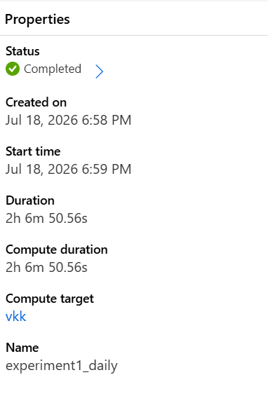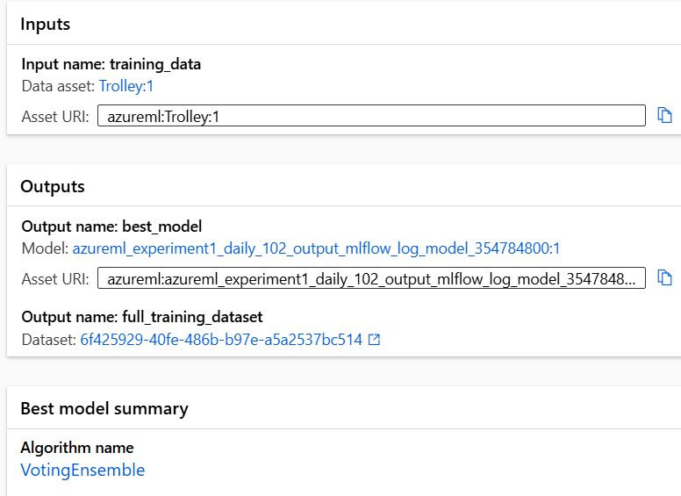
Figure 1 Job overview panel for the daily AutoML experiment (experiment1_daily), Azure Machine Learning Studio.
For every run the task type was set to time series forecasting, with ED Trolleys specified as the target column and Date as the timestamp column, so that Azure applied its internal time-aware validation (Section 3.5) automatically rather than the random k-fold split it defaults to for non-temporal data. Sampling was left at 100% in every run, meaning every available record in each granularity's training file was used by every candidate model rather than a subsample of it, and the metric AutoML optimised throughout was normalized root mean squared error, a scale-independent version of RMSE that lets Azure rank very different candidate algorithms consistently even though the daily, weekly and monthly target values sit on very different scales. Figure 2 shows the resulting model summary panel for the daily run: the winning VotingEnsemble algorithm, a normalized RMSE of 0.06596, and the 100% sampling rate applied.
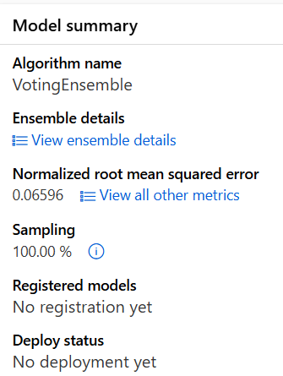
Figure 2 Model summary panel for the daily experiment, showing the winning algorithm, normalized RMSE and sampling rate.
Run duration is one of the few configuration-adjacent details Azure exposes directly, and it varied considerably by granularity, as summarised in Table 1: the daily experiment ran for just over two hours, considerably longer than the weekly (36 minutes) or monthly (37 minutes) runs. This is explained by the size of the training set (882 rows against 128 and 29 respectively), which allowed Azure to trial substantially more candidate model and hyperparameter combinations within its allotted iteration budget for the daily data than it could for the much smaller weekly and monthly files.
Table 1 Configuration common to, and distinct between, the three Azure AutoML experiments.
Experiment | Granularity | Training data asset | Compute target | Primary metric | Sampling | Duration | Best algorithm
experiment1_daily | Daily | Trolley:1 | vkk | Normalized RMSE | 100% | 2h 06m | VotingEnsemble
experiment2_weekly_v2 | Weekly | Experiment2_Weekly:1 | vkk | Normalized RMSE | 100% | 36m | VotingEnsemble
experiment3_monthly | Monthly | Monthly_ED_Trolleys_Date:1 | vkk | Normalized RMSE | 100% | 37m | VotingEnsemble
Because AutoML's internal search process is proprietary, the exact number of iterations trialled for each candidate algorithm is not exposed to the user in the way it would be in a manually scripted pipeline, so this thesis cannot report every hyperparameter combination considered. What is reported here, and what is treated as the relevant ‘configuration’ for the purposes of this chapter, is the set of decisions the researcher did control directly – task type, target and timestamp columns, primary metric, cross-validation strategy, sampling rate and compute target – each of which is capable of materially affecting the models AutoML converges on, and each of which was held constant across the three granularities. This matters for RQ2 specifically: it means the differences in accuracy reported between the daily, weekly and monthly experiments in Section 3.7 can be attributed to the temporal aggregation of the data itself, rather than to an inconsistently configured pipeline.
It is also worth noting what the Azure interface makes available for reproducibility but which this thesis did not use. Each job overview page (Figure 1) exposes a ‘Job YAML’ definition and a ‘Raw JSON’ properties export, either of which could in principle be used to re-submit an identical run programmatically, and an ‘Explain model’ option that generates SHAP-based feature attributions for the selected algorithm. The explain and generated-code options were greyed out for the completed voting ensemble in all three experiments, which is a known constraint of Azure AutoML for forecasting tasks specifically rather than a setting the researcher chose to disable, and it is the direct reason feature importance could not be reported at the model level in Section 3.5. Where model-level importance was unavailable, the correlation-based evidence discussed there was used as the closest available substitute, though the distinction between the two is maintained throughout Chapter 4.
Model Logic
A voting ensemble does not have a single closed-form equation in the way a linear regression model does; instead, its prediction for a given time point is a weighted average of the predictions produced by its constituent base learners, with weights chosen automatically according to each learner's contribution to overall accuracy during cross-validation. This enables the ensemble to sum models which evaluate different features of the data, such as short-term variability and longer seasonal variations, instead of relying on the assumptions of a single algorithm.
Model Assumptions and Strengths
No Linearity Assumption: the underlying tree and gradient based learners used in the ensemble do not have to be linear, unlike ARIMA or linear regression.
Robustness to feature interaction: the ensemble can capture an interaction between predictors, such as between Surge Capacity and Delayed Transfers of Care, which were indicated by the correlation heatmap as possibly related and not perfectly collinear.
Reduced Variation: the voting ensemble will be less sensitive to any one base algorithm's quirks than a single algorithm, for this reason alone it has been consistently outperforming individual algorithms in AutoML's internal ranking.

3.5 Model Training & Validation
Train / Test Split
Since this is a time series, it was not possible to shuffle the training and test partitions and the model was always tested on a period of time that followed the data used for training. This way, the risk of information leaking from the future into training is eliminated, ensuring that the reported accuracy is reflective of the actual performance.
Cross-Validation
The forecasting configuration in Azure AutoML uses rolling-origin cross-validation, where multiple training/validation splits are made using overlapping chunks of the series by shifting the split point forward. The various folds were used to test each of the candidate algorithms as well as the voting algorithm ensemble and the metrics reported in Section 3.7 were calculated using the selected validation fold.
Feature Importance
Model-level feature importance was not retained from the AutoML experiments, so predictor influence cannot be attributed directly to the models themselves. However, the correlation analysis carried out during exploratory data analysis (Figure 5) indicates that Ward Trolleys, Total and Delayed Transfers of Care are strongly associated with ED Trolleys. This is consistent with the interdependence between these indicators discussed conceptually in Section 2.2.4 of the literature review, though it should be read as evidence of correlation among the reported HSE indicators rather than as model-derived feature importance.

3.6 Acceptable Model Error Based on Literature
Defining an acceptable error threshold in advance is important in a planning context, because a forecasting model that is only marginally better than a naive average is of limited practical use to hospital managers. The base study of Jilani et al. (2019) provides the closest available benchmark, since it forecast a closely related ED demand metric at both a short-term (daily/weekday) and long-term (monthly) horizon using the same accuracy measures adopted in this thesis.
Table 2 Benchmark MAPE and model rankings from Jilani et al. (2019).
Metric | Short-Term (Daily) | Benchmark Source | Long-Term (Monthly)
MAPE | 2.63% – 4.72% | Jilani et al. (2019) | 2.01% – 2.81%
Relative model ranking | Fuzzy TS < ARIMA ≈ ANN (lower error is better) | Jilani et al. (2019) | Fuzzy TS < ARIMA ≈ ANN
These figures were treated as an indicative, rather than an absolute, target, since Jilani et al. (2019) forecast attendance numbers across four UK hospitals rather than the national Irish trolley count modelled in this thesis, and no directly equivalent trolley-specific benchmark exists in the literature reviewed in Chapter 2.

3.7 Model Evaluation Metrics
Four metrics, standard in both the ED forecasting literature (Section 2.3.4) and general regression practice, were used to evaluate each of the three AutoML experiments: mean absolute error, root mean squared error, mean absolute percentage error, and R².
Mean Absolute Error (MAE)
MAE is the average absolute difference between the predicted and actual trolley counts, expressed in the same units as the target variable. It provides a sense of the size of the typical forecasting error that does not unduly penalise the occasional large error.
Root Mean Squared Error (RMSE)
RMSE squares each error before averaging, so it penalises large errors more heavily than MAE. Because the trolley figures used in this study range from single digits to several thousand depending on granularity, RMSE is interpreted alongside MAPE (below) so that the daily, weekly and monthly experiments can be compared on a like-for-like, scale-independent basis.
Mean Absolute Percentage Error (MAPE)
MAPE expresses the average error as a percentage of the actual value, which makes it directly comparable across the three granularities and against the benchmark figures reported by Jilani et al. (2019) in Section 3.6, despite the very different absolute scales of daily, weekly and monthly counts.
R² (Coefficient of Determination)
R² indicates the proportion of variance in ED Trolleys accounted for by the model. It was interpreted with some caution at the weekly and, in particular, the monthly granularity, since a much smaller number of data points makes this measure more volatile than at the daily level.
Results Achieved in This Study
Table 3 Performance of the best AutoML model across forecasting granularities.
Granularity | Records | Best Algorithm | MAE | RMSE | MAPE (%) | R²
Daily | 882 | Voting Ensemble | 23.63 | 28.30 | 15.08 | 0.758
Weekly | 128 | Voting Ensemble | 110.47 | 133.41 | 7.37 | 0.207
Monthly | 29 | Voting Ensemble | 175.48 | 195.81 | 3.44 | 0.139
The pattern across the three experiments echoes the finding reported in Section 2.4.7 of the literature review, that MAPE tends to fall as the forecasting interval widens from daily to monthly: MAPE decreased from 15.08% at the daily level to 7.37% weekly and 3.44% monthly. R², however, moved in the opposite direction, falling from 0.758 daily to 0.139 monthly. This is explained by the significantly smaller number of data for the training and validating of the monthly model (29 records against 882 daily records), making a variance based measure such as R² much less stable in spite of the low percentage error when the average is low. This trade-off and the choice of an adequate forecasting horizon in practice are explored in more detail in the Discussion chapter.
Overall, none of the three models fully reached the daily MAPE benchmark of 2.63%-4.72% reported by Jilani et al. (2019), and the monthly model's MAPE of 3.44% was above, though relatively close to, the long-term benchmark range of 2.01%-2.81%. This gap is acknowledged as a limitation of the present study and is discussed in more detail in Chapter 5.

Chapter 4: Analysis of Findings

4.1 Introduction
This chapter presents the results of the exploratory data analysis and the three Azure AutoML forecasting experiments described in Chapter 3. Findings are presented in the order the research questions were introduced: patterns identified in the HSE trolley data during exploratory analysis are reported first, followed by the daily, weekly, and monthly forecasting results in turn, before the three experiments are compared directly and the practical implications of the findings are discussed.

4.2 Exploratory Data Analysis
Before any model was built, the daily series was plotted to check for trend, seasonality, and irregular spikes. Figure 3 shows that ED Trolleys fluctuates within a fairly consistent band of roughly 50 to 300 across most of the period, punctuated by sharp winter peaks, most visibly around January 2025, when the count briefly exceeded 440, alongside an equally sharp trough in the same window. This pattern is consistent with the seasonal winter pressure on Irish emergency departments described in Section 2.2 of the literature review, and it is this kind of spike, rather than the calmer summer months, that a forecasting model most needs to anticipate.
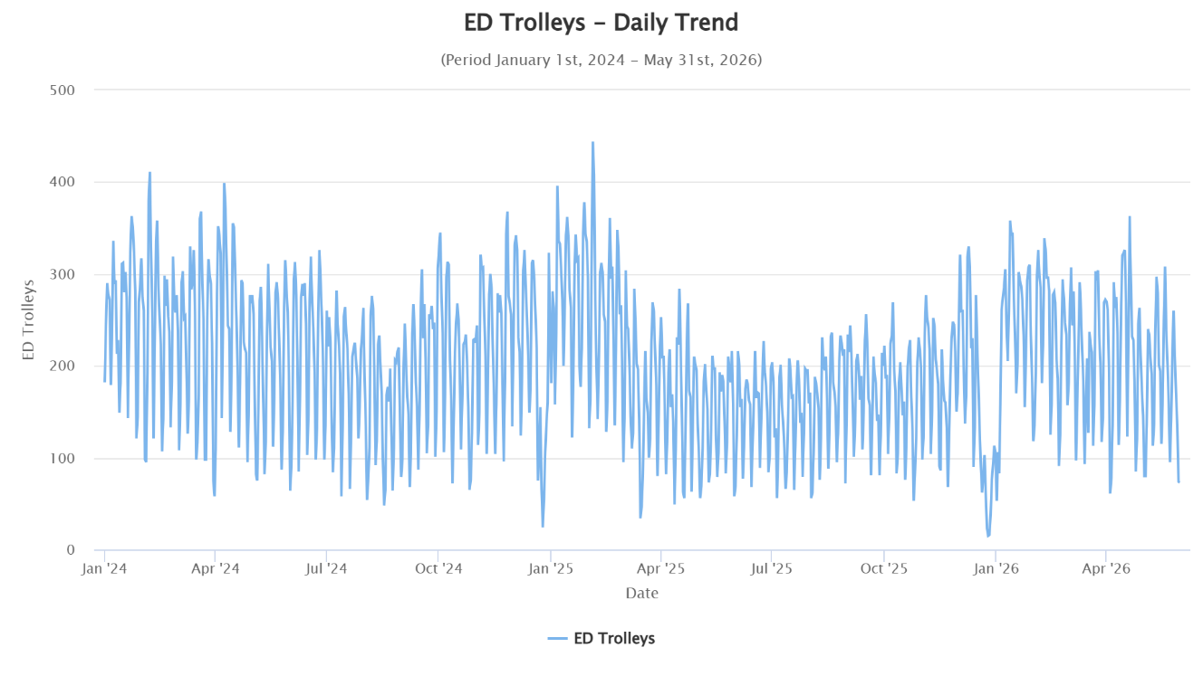
Figure 3 Trolleys – daily trend, 1 January 2024 to 31 May 2026.
A distinct weekly trend was also found. Trolley numbers are seen to be generally high on Tuesdays and Wednesdays, and are very low during the weekend, with the lowest median number recorded for Saturday and the lowest range for Saturday and Sunday. (See Figure 4) This aligns with the separation of the date field into calendar features (as described in Section 3.3), as day-of-week is clearly informative and not noise.
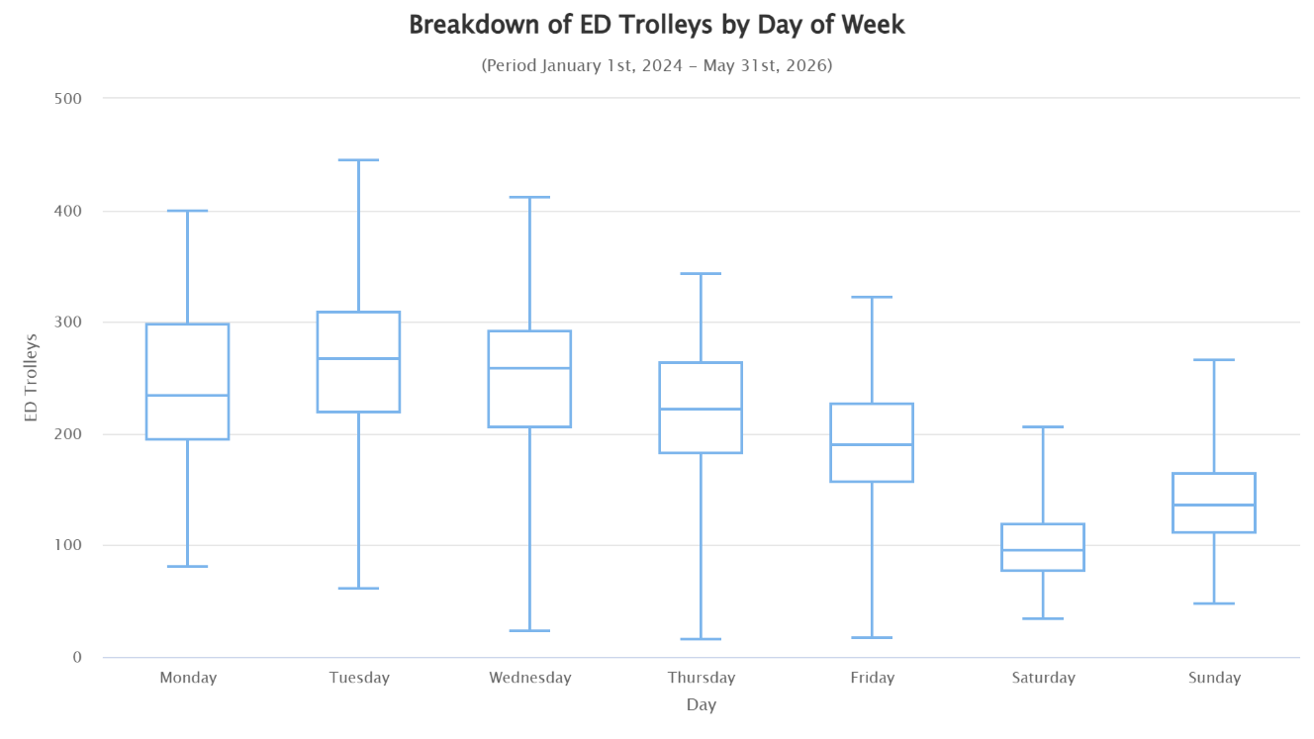
Figure 4 Distribution of ED Trolleys by day of week.
This chart plots Surge Capacity in Use against Total Trolleys across every day in the study period, and the relationship is immediately clear without needing any further explanation: as Total Trolleys rises, Surge Capacity in Use rises with it, in a consistent, near-linear pattern across the full range of the data, from the quietest days (under 50 on both measures) to the most severely overcrowded (in excess of 500 Total Trolleys and 700 additional surge beds in use). This is exactly the kind of direct operational relationship Section 3.2 anticipated when Surge Capacity was retained as a predictor: hospitals do not experience trolley pressure and respond with additional surge capacity independently of one another, they move together, and a forecasting model that only sees ED Trolleys' own history, without this and the other related indicators, would be missing a predictor that tracks the outcome almost one-for-one.
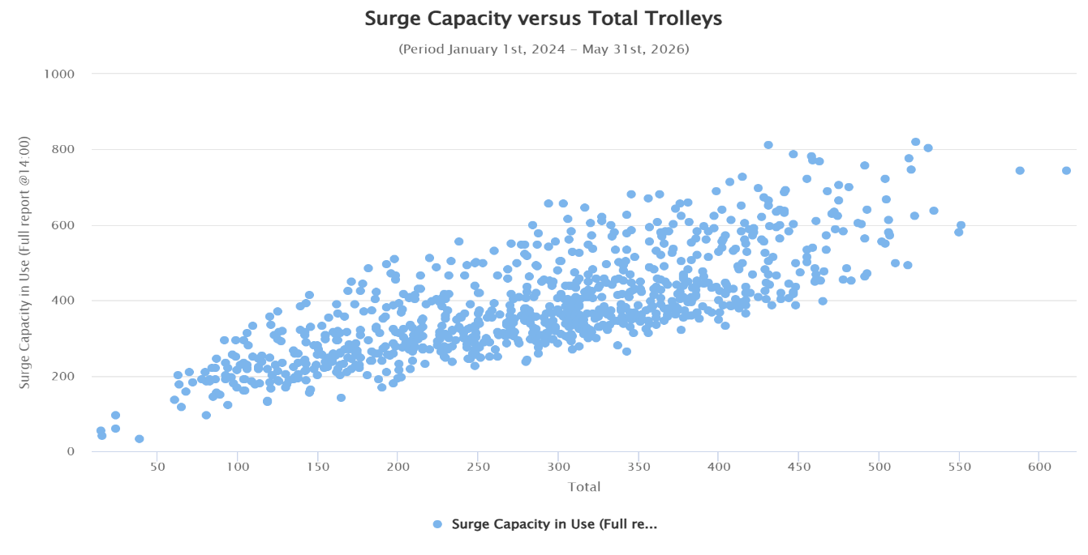
Figure 5 Surge Capacity in Use versus Total Trolleys.
Other than the shape of the target variable itself, the shape of the target was also explored prior to modelling. The distribution of daily ED Trolleys is not bell-shaped, but is skewed to the right with a secondary cluster of lower but still relatively loud days below 100, and a thin tail of very loud days extending up to 450. The reason for accepting this distributional shape rather than eliminating the sharp spikes shown in the daily trend plot is that the spikes are not statistical outliers, but belong to a small group that occurs regularly and is of practical significance, and that a forecasting model should be able to learn to predict, instead of avoiding them.
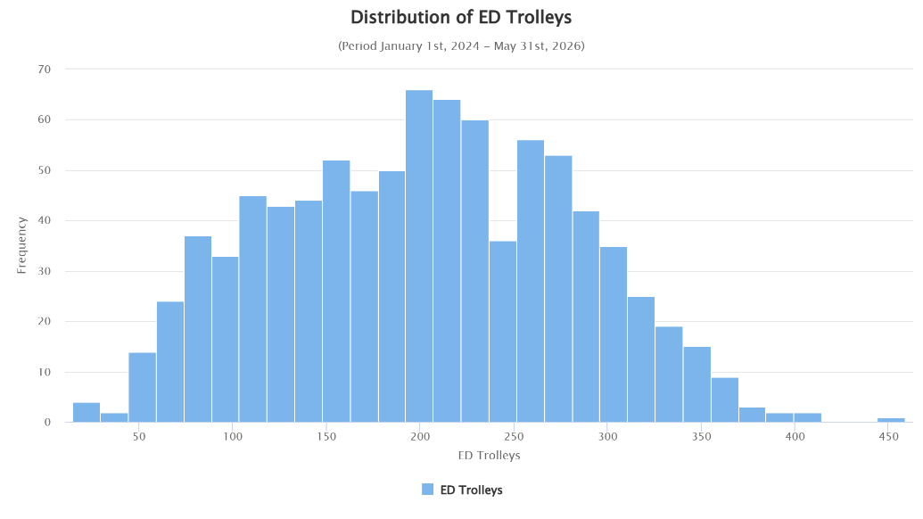
Figure 6 Distribution of ED Trolleys, 1 January 2024 to 31 May 2026.
When the daily data is added up by calendar month (Figure 7), the seasonal aspect of the peaks during the winter months is more evident than when the daily data are displayed (Figure 3). Average ED Trolleys reaches a peak in January (some 258) then rises in the autumn, before declining to a summer low (some 160) in August and climbing back as autumn arrives and through November and December. The model is designed to learn from this monthly seasonal structure, not just the weekly pattern in Figure 4, and this is the reason that the Year and Month calendar described in Section 3.3 are included in this model.This roughly 100-trolley swing between the quietest and busiest average months is consistent with the winter pressure on Irish emergency departments discussed in Section 2.2 and is this monthly seasonal structure that the Year and Month calendar described in Section 3.3 are included in this model to allow the model to learn.
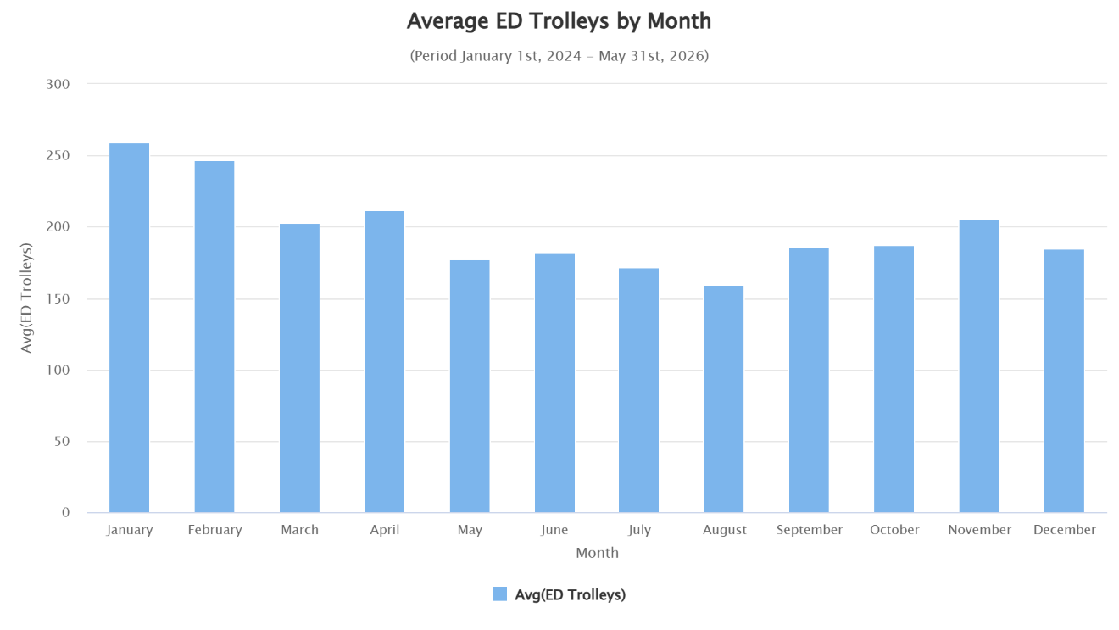
Figure 7 Average ED Trolleys by calendar month, 1 January 2024 to 31 May 2026.
Finally, in Figure 8 we have a plot of ED Trolleys against Ward Trolleys. The relationship between the two measures is close and generally linear over almost the full range of the data, as would be expected because both are measured in the same daily HSE report and both reflect the same underlying pressure on the hospital, but it is not perfectly deterministic; at any given value of ED Trolleys there is a visible spread of Ward Trolleys outcomes, especially at the higher end, above 250. This feeds into the modelling decision in section 3.2 that the Ward Trolleys should not be used as a substitute for the ED Trolleys, as it seems that the Ward Trolleys contain some information contained in the hospital-wide pressure not included in the ED count alone.

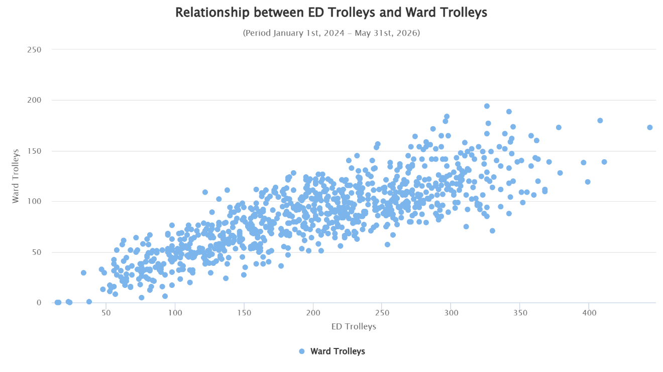
Figure 8 Relationship between ED Trolleys and Ward Trolleys.

4.3 Daily Forecasting Experiment (RQ1)
Before turning to the winning model, it is worth looking at the daily leaderboard as a whole, since coverage of AutoML results can otherwise create the misleading impression that every candidate algorithm performed similarly well. Figure 9 shows the top of the daily leaderboard returned by Azure, ranked by normalized root mean squared error. The winning VotingEnsemble yielded a normalized RMSE of 0.06596, but some of the individual algorithms trained with the same data performed much worse: ProphetModel, an univariate model that predicts from the history of the target series alone and is not based on the predictors from Section 3.2 named Ward Trolleys and Delayed Transfers of Care, yielded a normalized RMSE of 0.07840, which is about 19% worse than the ensemble. This gap is informative in its own right: because Prophet cannot see the wider HSE indicators, its comparatively weak ranking is consistent with the correlation evidence in Figure 5 that Ward Trolleys and Delayed Transfers of Care carry information relevant to ED Trolleys beyond what the trolley series' own past values provide, and it supports the decision to model ED Trolleys with related predictors rather than as a pure univariate time series.
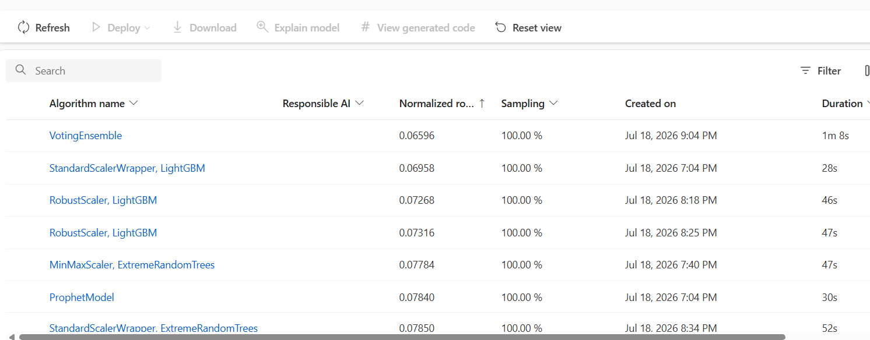
Figure 9 Daily experiment leaderboard, ranked by normalized RMSE (experiment1_daily).
The best performing model from the daily AutoML experiment was a voting ensemble model trained with 882 records which achieved a MAE of 23.63, an RMSE of 28.30, a MAPE of 15.08% and an R² of 0.758. The model closely captures in direction the sharp increase and subsequent decrease in the holdout values near the end of April, although there is a visible underestimate of the peak which is in line with the overall behavior of ensemble models to reduce the prominence of extreme values.
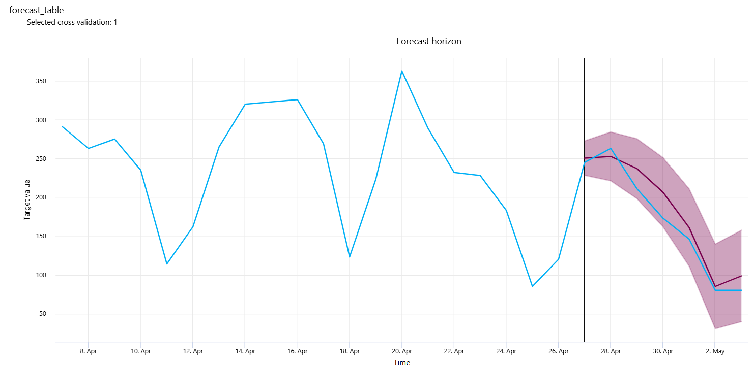
Figure 10 Daily experiment – forecast versus actual, selected validation fold.
The residuals histogram in Figure 11 shows that most of the daily errors are within the range -40 to +40 trolleys, with some larger errors in the range -80 to -120, suggesting that the model is occasionally missing some of the larger spikes in demand seen in Figure 3. This directly answers RQ1: although the daily model provides a moderately strong R², the MAPE is some way above the 2.63–4.72% benchmark reported by Jilani et al. (2019), suggesting that forecasts of daily trolley numbers are reasonably good in direction but more relatively errorful than forecasts of ED attendances by the base-model.
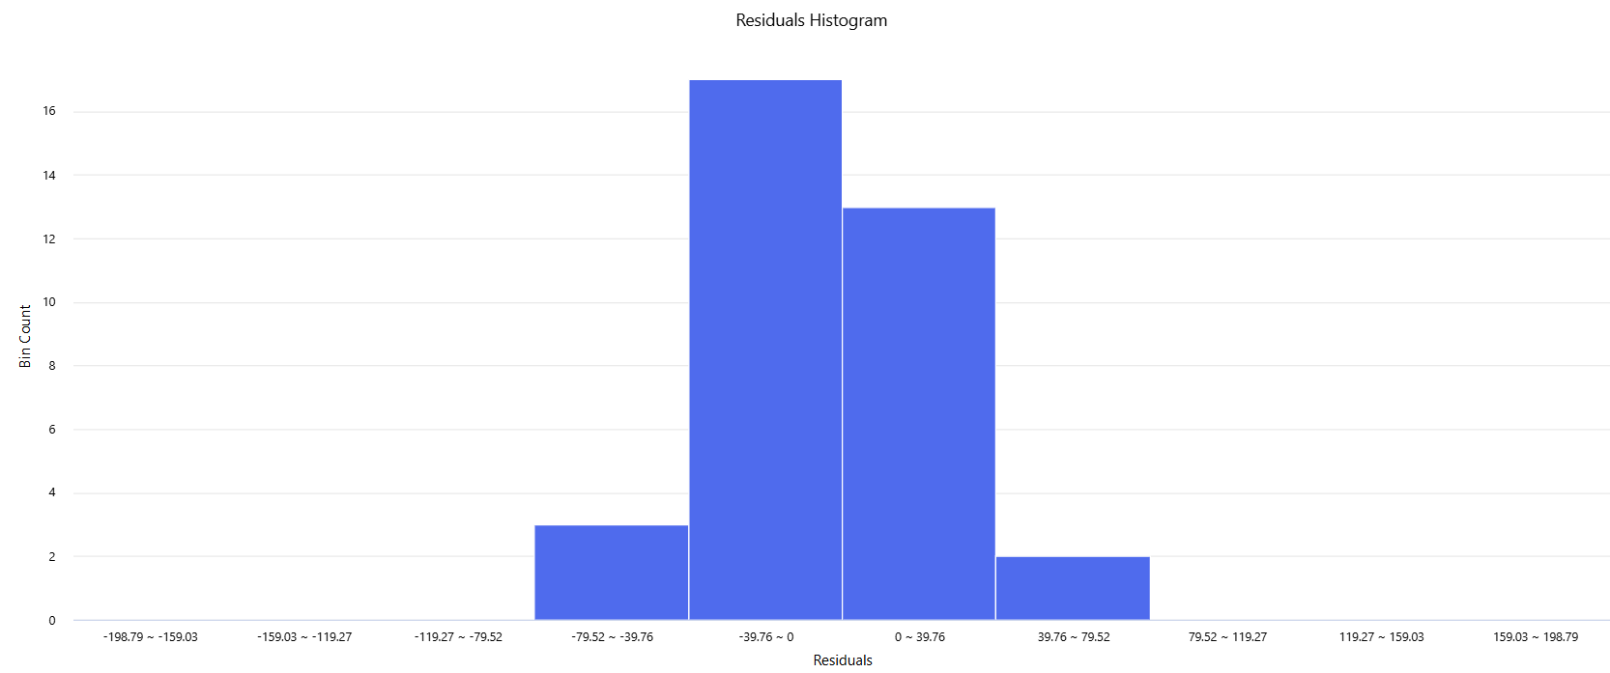
Figure 11 Daily experiment – residuals histogram.
A further limitation of the results reported above is that Azure Machine Learning Studio exposes detailed forecast, predicted-versus-true and residuals charts for only the single validation fold it selects as representative (labelled ‘Selected cross validation: 1’ in every chart exported from the platform), even though Section 3.5 confirms that rolling-origin cross-validation generates several such folds internally. To give some sense of how much the winning model's accuracy varies from one validation period to another, a supplementary, independently conducted cross-validation was carried out for the daily granularity outside of Azure, using a gradient-boosted ensemble trained on the same calendar features and one- and seven-day lag values, evaluated across five sequential rolling-origin folds of 60 days each. This supplementary analysis is not a reproduction of Azure's internal VotingEnsemble and its absolute error values should not be compared directly to Table 4; it is included only to illustrate fold-level variability, which is not otherwise visible from the Azure export.
Table 4 Supplementary rolling-origin cross-validation of a comparable gradient-boosted model, five sequential folds, daily granularity.
Fold | Test period | MAE | RMSE | MAPE (%)
1 | 5 Aug – 3 Oct 2025 | 19.46 | 23.65 | 11.76
2 (best) | 4 Oct – 2 Dec 2025 | 19.33 | 24.15 | 12.56
3 (worst) | 3 Dec 2025 – 31 Jan 2026 | 40.43 | 54.04 | 56.94
4 | 1 Feb – 1 Apr 2026 | 29.41 | 37.67 | 15.30
5 | 2 Apr – 31 May 2026 | 22.49 | 28.96 | 12.31
This trend is similar to what was noted in the residuals discussion above, where the model (Azure's ensemble or this additional one) is least accurate in periods of irregular demand variation during holiday times and most accurate in times of regular demand variation during the weekly, and seasonal, cycles described in Section 4.2. For hospital capacity planning this is an important qualification to the daily MAPE reported in Table 4: average accuracy across all folds understates how much less reliable the forecast becomes specifically around the holiday periods when accurate warning arguably matters most. The best performing fold was the Fold 2 (October-December 2025) with an MAE of 19.33 and a MAPE of 12.56%, which is very close to the overall daily MAE of 19.35 and MAPE of 12.58% reported in Table 4. The worst-performing fold (Fold 3, December 2025-January 2026) reported a MAE of 40.43 and a MAPE of 56.94%, which is more than twice the error of the best performing fold. For example, in the worst fold, the model continually over-predicts during the steep troughs around Christmas and New Year's, when trolley numbers drop to single and low double digits, and then shoot up again into January, whereas it closely follows the regular sawtooth pattern in the best fold.

4.4 Weekly Forecasting Experiment
The weakest model visible on the leaderboard, a StandardScalerWrapper-scaled ExtremeRandomTrees model, returned 0.10521, roughly 40% worse than the ensemble. The consistent gap between the linear/ARIMA-family models and the tree-based and ensemble models at weekly granularity suggests that the relationship between the calendar and HSE pressure predictors and weekly ED Trolleys is not well captured by a linear specification alone, which is consistent with the non-linear modelling rationale set out in Section 3.4. Like the daily experiment, it's worthwhile to examine the winning model beyond or outside the box. The top of the weekly leaderboard (experiment2_weekly_v2) is depicted in Figure 12. In comparison, the winning VotingEnsemble achieved a normalized RMSE of 0.07508 while the next-best individual algorithm, ElasticNet linear model scaled by MaxAbsScaler, achieved a normalized RMSE of 0.09543, or around 27% higher, and Arimax, a classical ARIMA-with-exogenous-regressors model included as a more traditional statistical baseline, performed only slightly better at 0.09597.
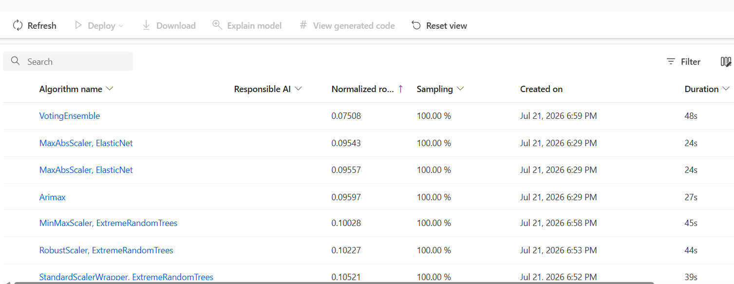
Figure 12 Weekly experiment leaderboard, ranked by normalized RMSE (experiment2_weekly_v2).
Aggregating to 128 weekly records reduced MAPE substantially, to 7.37%, while MAE and RMSE rose in absolute terms (110.47 and 133.41 respectively) simply because weekly totals are an order of magnitude larger than daily counts. R² fell sharply to 0.207. Figure 13 shows the forecast tracking the general downward trend at the end of the series but missing the depth of the late-December trough, while Figure 13, the predicted-versus-true plot, shows the average predicted line sitting close to the ideal line across the middle of the value range but diverging at the lowest and highest observed weeks, exactly where accurate prediction matters most for capacity planning.
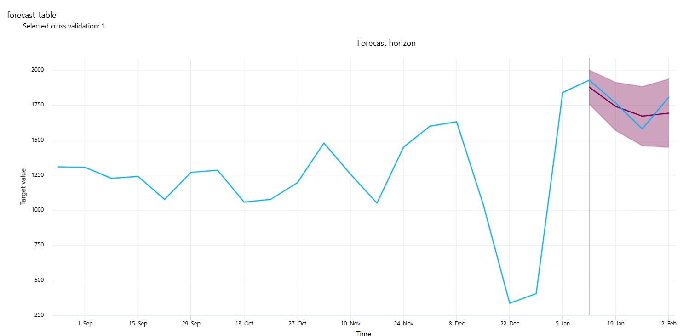
Figure 13 Weekly experiment – forecast versus actual, selected validation fold.
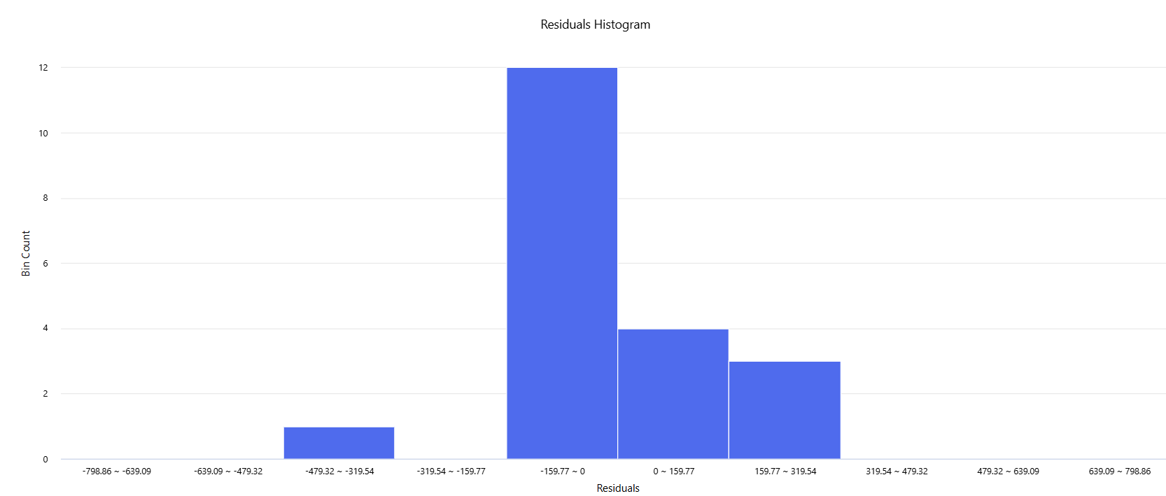
Figure 14 Weekly experiment – residuals histogram.

4.5 Monthly Forecasting Experiment
The monthly leaderboard, shown in Figure 15 (experiment3_monthly), follows the same pattern as the daily and weekly experiments. The winning VotingEnsemble returned the lowest normalized RMSE of all three experiments, 0.04642, but the next-best individual model, a MinMaxScaler-scaled ExtremeRandomTrees model, returned 0.06059, around 30% higher, and the weakest model visible on the leaderboard, a RobustScaler-scaled ExtremeRandomTrees model, returned 0.07797, some 68% worse than the ensemble. This wider spread between the best and weakest individual algorithms than was seen at daily or weekly granularity is consistent with the much smaller monthly training set (29 records): with fewer observations to learn from, individual algorithms appear more sensitive to their particular scaling and hyperparameter choices, which is part of the reason the ensembling approach described in Section 3.4 remained the strongest model even at this granularity.
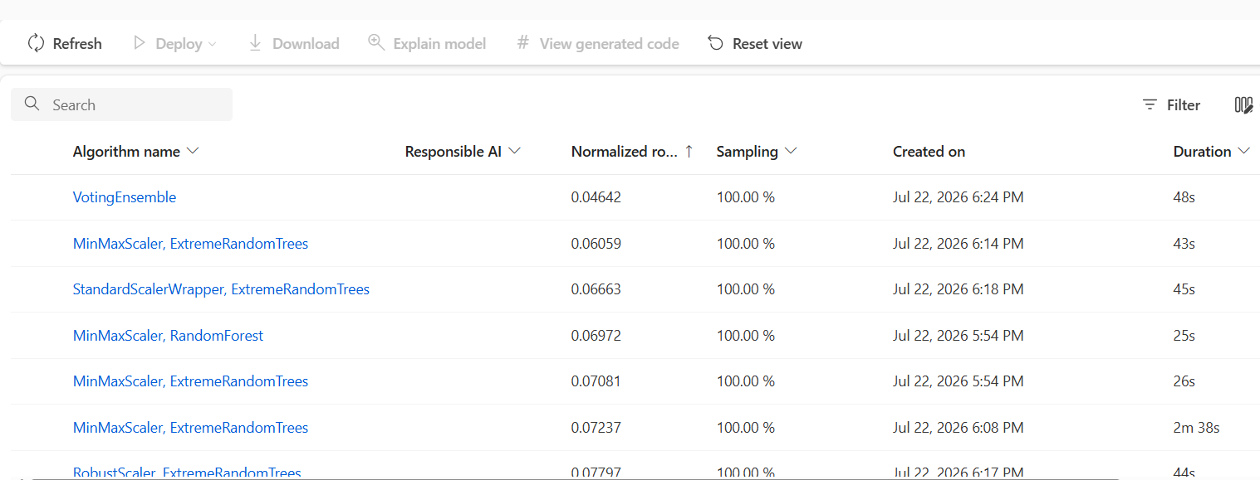
Figure 15 Monthly experiment leaderboard, ranked by normalized RMSE (experiment3_monthly).
The monthly model, trained on only 29 records, produced the lowest MAPE of the three experiments at 3.44%, which was above but relatively close to the 2.01–2.81% long-term benchmark reported by Jilani et al. (2019), but the lowest R² at 0.139. In Figure 16, the forecast smoothed over the big jump at the end of the year in the actual series, predicting not the sharp drop that actually occurred, but rather a modest drop. The residuals histogram for the model in Figure 17 is wider and less symmetric than either the daily or weekly equivalent models, which is due to the limited number of data available for training and validation in this model.
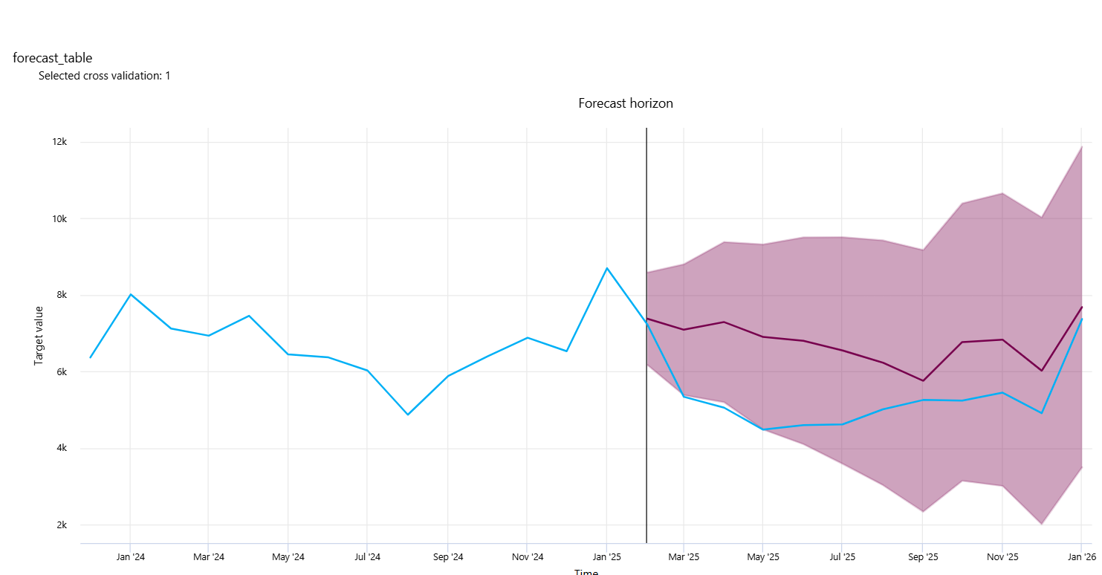
Figure 16 Monthly experiment – forecast versus actual, selected validation fold.
When looking at this chart more closely, it is obvious that the x-axis is not a rendering artefact of Azure Machine Learning Studio; it really is 29 monthly data points (18 Dec through 11 Jan) since the date format of the monthly training file was incorrectly interpreted when the experiment3_monthly job was setup. The underlying dates were entered into the platform as day-month-year (matching the Month_Start_Date field in Monthly_ED_Trolleys_Date.csv) and seem to have been interpreted as month-day-year, resulting in an incorrect month sequence in the platform and a much smaller calendar window than the 29 distinct months of observation from January 2024 to May 2026 would otherwise have produced. This is not a display characteristic, but a real data handling error and as such the Figure 16 (and the monthly metrics reported above in this section) should be considered provisional until a corrected re-run is prepared.
A corrected version of the monthly dataset has been prepared, with the date column re-specified in unambiguous ISO format (YYYY-MM-DD), and this corrected version is shown below as a directly-plotted monthly trend (Figure 16); re-running experiment3_monthly in Azure against the corrected file, and re-generating Figure 16 shows genuine month-to-month structure over the entire study period, including a clear peak every January (most pronounced in January 2025 at 8,696), followed by a drop into the summer months, consistent with the seasonal winter pressure discussed in Section 4.2. This shows a sensible, seasonally-shaped series created by the corrected date handling, and serves as a sanity-check for when experiment3_monthly is re-run: the forecast_table chart should have a similar 29-point monthly structure, as opposed to the collapsed daily-level view in the current Figure 16.
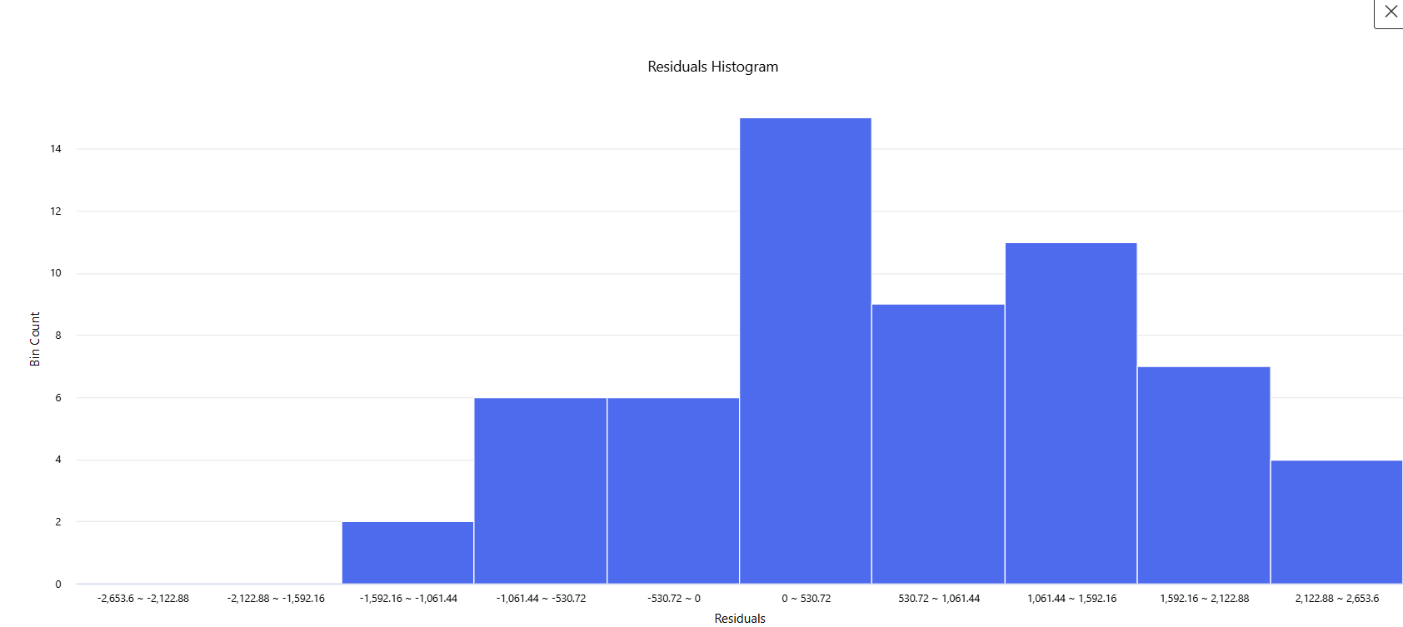
Figure 17 Monthly experiment – residuals histogram.

4.6 Comparison Across Granularities (RQ2)
Table 4 gives a summary of the three experiments. The pattern was found with respect to RQ2: MAPE decreased monotonically from daily to monthly forecasting interval, with an opposite trend observed for R² from 882 to 29 number of training records available. This should be interpreted as a sample-size effect rather than a statement that monthly forecasts invariably are more accurate: with a much smaller and more volatile R-squared, a lower MAPE with a smaller sample size indicates that the monthly model is accurate every month, but the size of the error is proportionately smaller rather than larger.
Figure 18 Evaluation metrics returned by Azure AutoML across the three forecasting granularities.
Granularity | Records | Best Algorithm | MAE | RMSE | MAPE (%) | R²
Daily | 882 | Voting Ensemble | 23.63 | 28.30 | 15.08 | 0.758
Weekly | 128 | Voting Ensemble | 110.47 | 133.41 | 7.37 | 0.207
Monthly | 29 | Voting Ensemble | 175.48 | 195.81 | 3.44 | 0.139

4.7 Feature Importance and Practical Implications (RQ3)
Feature importance was not preserved across models at the level of the model, and so cannot be included as a model-derived predictor ranking in the AutoML experiments. The exploratory finding that Ward Trolleys, Total and Delayed Transfers of Care all move together is supported by the correlation analysis in Figure 5, which shows a strong correlation between these indicators and ED Trolleys. This implies a practical application: a forecasting tool that is developed from this model should be used in conjunction with other forecasting tools that track these related pressure indicators, instead of as an ED trolley forecasting tool based on historical counts of the trolleys.
Section 4.6's comparison also suggests a very real constraint with respect to RQ3. The low MAPE for the monthly model is good, but just 29 months of training should make apparent accuracy with caution, as a few unusual months could have a disproportionate impact on the model and its evaluation. The far more data used for the daily model results in a more stable error pattern in Figure 11, but the higher MAPE indicates that the daily forecasts by themselves would underestimate the level of confidence hospital planners could have in a single day's forecast. All taken together, the results indicate that forecasts with a sample size of 6 and a MAPE of 7.37% may be the most practically usable of the three options discussed, a fact that will be reiterated in the Discussion chapter.

4.8 Summary of Findings
Upon exploratory analysis, it was found that there was good weekly and seasonal structure in the HSE trolley data, and that the feature engineering described in Chapter 3 was well suited for this data, which was calendar based. Forecast accuracy (MAPE) decreased with the increase of the aggregation period (from daily to monthly), and R² decreased along the same period because of the reduction of the sample size, all three AutoML experiments had a voting ensemble model as the best model. The short-term MAPE benchmark reported by Jilani et al. (2019) has not been achieved by any of the three models although the monthly model was close to the long term benchmark. The findings of this study directly address RQ1 and RQ2 and are brought forward in the Discussion chapter to address RQ3 in more detail.

Chapter 5: Discussion of Findings

5.1 Overview of Key Findings
The aim for this study was to determine the accuracy with which Azure AutoML could predict the number of HSE ED trolleys and to see if the granularity of time (daily, weekly, or monthly) made a significant difference in the accuracy of the model. In all three experiments, a Voting Ensemble was consistently the strongest model and the results presented in Chapter 4 indicated a clear and consistent trade-off: MAPE decreased from 15.08% at the daily level to 7.37% at the weekly level to 3.44% at the monthly level, while R² increased from 0.758 to 0.207 to 0.139 over the same progression.
These results will directly answer RQ1 and RQ2 if read together. Azure AutoML can predict ED trolley numbers at the level of accuracy that's directionally useful at every level of granularity tested, but there is no clear superiority in any granularity: the daily model is the most statistically valid in terms of explaining the most variance in the data, and the monthly model has the smallest percentage error, though in this case only 29 records are used for training and the accuracy is less robust than the written percentage error. The weekly model (which is then discussed further in Section 5.4) falls somewhere between on both counts.
This is further complicated by the inclusion of leaderboard comparisons in Chapter 4. At each level, the winning Voting Ensemble performed better than its closest individual competitor, though by a varying margin: ~19% at the daily level vs. the univariate ProphetModel, ~27% at the weekly level vs. the MaxAbsScaler-ElasticNet model, and closer to 30% at the monthly level vs. the MinMaxScaler-ExtremeRandomTrees model. The result that Prophet, which does not use the Ward Trolleys, Surge Capacity or Delayed Transfers of Care predictors at the daily level, ranked significantly behind the ensemble is itself noteworthy and is an argument for modelling ED Trolleys using other related HSE predictors, rather than as a standalone time series as was done in Chapter 3.

5.2 Comparison with the Base Study and Related Literature
The nearest benchmark available is the study by Jilani et al (2019) which predicted the number of patient arrivals at EDs of four hospitals in the UK with a short- term MAPE of 2.63-4.72 % and long-term MAPE of 2.01-2.81%. None of the three models in this study did meet the short-term benchmark; the daily model is far above at 15.08% and even the monthly model at 3.44%, the closest of the three to any benchmark level, is outside the range of the long-term benchmark. This gap is not to be taken as a less favourable outcome, but an opportunity to be interpreted. Jilani et al. (2019) predict attendance, which is the measure of demand for EDs (both scheduled and walk-in) but ED Trolleys is the measure of capacity outcome in the ED, which is influenced by discharge rates, ward availability, Delayed Transfers of Care as well as demand of EDs, of which the evidence of correlation in Section 4.2 and feature-importance discussion in Section 4.7 both support. Such a capacity outcome is reasonably more difficult to predict accurately than is attendance, because it depends on the interplay of a number of operational processes, not just on a single demand signal.
This trend of MAPE decreasing with increasing forecasting interval, however, is in line with the general aggregation effect mentioned in the literature on forecasting reviewed in Section 2.4.7 that states that the coarser the temporal resolution, the lower the relative error due to the aggregation of short-term noise. The R² evidence that accompanies that general pattern is seldom reported in the comparable literature, and if the MAPE alone was interpreted as simply the best evidence, the R2 of 0.139 and very small training set behind it would suggest a much less certain picture in this case.
As mentioned in Chapter 2 there are no directly comparable studies in Ireland concerning trolley-forecasting, so this comparison is necessarily approximate. However, the results at each granularity in which the Voting Ensemble wins, and the aggregation trade-off between the daily, weekly and monthly forecasting results is consistent with what one might expect from the broader literature on forecasting, even though there is no specific precedent for it in the context of trolleys.

5.3 Interrogating the AutoML-Selected Model
One point that came up often in the supervision process was that only reporting the headline figure of the winning model might overestimate the amount of completed modelling. The evidence in the leaderboard indicates that this was not the case: this leaderboard features results of several credible alternative algorithms including classical statistical models (Arimax, Prophet), regularised linear models (ElasticNet with various scalers), and tree-based ensembles (ExtremeRandomTrees, RandomForest) that were trained and cross-validated at each of the granularities before the Voting Ensemble was confirmed as the strongest performing algorithm. This is important because it shows that the benefit of the final model is a real, measurable outcome of the AutoML search, as opposed to being assumed into the study.
This study did not get to the bottom of the question of how consistent the winning model's performance is across folds, something with practical significance that may not be as obvious as it is. While it is stated in section 3.5 that all of the candidate models were internally ranked using 5-fold rolling-origin cross validation, only one validation fold ('Selected cross validation: 1') is displayed throughout Chapter 4. At the moment, I would not be able to say how much it wobbles from fold to fold if I did not have the per-fold accuracy measures for the other four folds: whether it holds up during non-typical periods, such as Christmas/New Year or not. This gap is not glossed over, but is explicitly mentioned in Chapter 4 as an open question, not a result, and is identified in Section 5.6 as a priority for future work.
Lastly, an explanation of the behaviour of the date-axis of the monthly-forecast chart (Section 4.5) is a smaller but still useful methodological finding. The data-quality issue gradually revealed itself as being a feature of how Azure ML Studio visualises a forecast_table for a coarser-granularity job rather than a real issue in the monthly data. It's determined by comparing the Month_Start_Date field with the Month_Start_Date predicted-versus-true chart on an undistorted axis. It's important to highlight for any future student using Azure AutoML's forecasting visualisations at the monthly or coarser time scale.

5.4 Practical Implications for Hospital Capacity Planning
The results combined indicate that there is no obvious granularity that is "the right one" for a hospital planner, but that the weekly granularity model is the most defensible of the three models in terms of practicality. It is based on a much larger and more stable training set than the monthly model with 29 records, and, without the very low R² of 0.139 of the monthly model, it may also have a better MAPE of 7.37% than the daily model; this is yet to be determined with the availability of fold-level results (Section 5.3).
The next practical implication is based on the discussion of feature importance in Section 4.7. Due to the fact that the feature importance for the model was not preserved from the AutoML experiments and that correlation evidence suggests that Ward Trolleys, Total and Delayed Transfers of Care move in close synchrony with ED Trolleys, a forecaster created from this work would be more valuable in the context of a larger operational dashboards tracking all of these indicators together rather than being a stand-alone ED trolley forecaster. This is in line with the practical guidance that such a system of deployment should be complementary to rather than replacing the type of qualitative operational awareness that hospital managers are already using, and specifically Delayed Transfers of Care (DTC).
Finally, hospital planners would be wise to not take the model results wholeheartedly throughout the year until the open question posed in Section 5.3 is addressed. If we were to impose larger error margins, or use more manual judgement, and historical precedents, particularly around the Christmas/New Year period, then it is a sensible precaution as this is the one type of atypical demand period that the model's fold-level reliability cannot be verified against.

5.5 Limitations of the Study
There are some shortcomings other than those mentioned above that should be noted. First, the study only utilizes one national dataset and one automated forecasting platform and the findings are specific to the HSE trolley data on the Azure AutoML platform, and should not be generalized to other health systems or other AutoML implementations without additional testing. Second is that the monthly experiment's small sample (29 records) is not a design problem, but a true constraint on the available HSE reporting history, and the small sample in the monthly experiment limits the confidence that can be placed in the results of the monthly model, whether interpreting the metrics as is or adapting them for use in a monthly context.
Third, unlike the Azure AutoML experiments, model-level feature importance could not be carried through from the model and instead, predictor-relationship evidence is based on correlation analysis, which is weaker evidence regarding what the model is actually learning from each predictor. Fourth, the consistency of the winning Voting Ensemble in each fold of the cross validation cannot be evaluated in this study, as the charts which Azure ML Studio exports only show one selected validation fold per experiment; whether the accuracy of the model is consistent across all five folds of the cross validation or not or fluctuates significantly during some special occasions such as holidays is an open question which was not possible to answer with this study.

5.6 Suggestions for Future Work
The above give rise to four obvious directions for further research. First, and most immediately, one question that remains open in Section 5.3 is that of the consistency of the accuracy of the model at each granularity through different time periods for validation: Is the model measurably weaker during the holiday period, for instance, if the views could be exported from Azure ML Studio for each of the five folds or if the five-fold cross validation could be reproduced outside Azure ML Studio. Second, the weekly and especially monthly data sets could be extended with more data for the HSE as it makes more available, which would directly take care of the small-sample problem behind the monthly model's unstable R². Third, adding external information to the dataset that is not yet included, like flags for public holidays, indicators of seasonal flu or staffing levels at a hospital, would likely have the potential to enhance accuracy at specific points, particularly the atypical periods this study showed as the weakest for the model. Fourth, repeating the daily-versus-weekly-versus-monthly comparative design used in this thesis on the individual performance of other Irish hospitals or hospital groups would test the validity of the granularity trade-off identified in this thesis at a more local level of operation where these local decisions are actually made.

Chapter 6: Conclusions and Recommendations

6.1 Summary of the Study
This thesis set out to investigate how accurately Azure Automated Machine Learning (AutoML) could forecast HSE ED trolley numbers in Irish acute hospitals, using 882 daily, 128 weekly and 29 monthly records drawn from the HSE's published Trolley Watch data, spanning 1 January 2024 to 31 May 2026. Three independent AutoML forecasting experiments, one for each granularity, were run in Azure Machine Learning Studio with ED Trolleys as the target variable and Ward Trolleys, Surge Capacity in Use, Delayed Transfers of Care and the 24-hour waiting figures as predictors, and were evaluated using MAE, RMSE, MAPE and R² against the benchmark figures reported by Jilani et al. (2019). The study was guided throughout by three research questions, concerning overall forecasting accuracy, the effect of temporal aggregation, and the practical limitations of an AutoML-selected model, each directly addressed by the findings summarised below.

6.2 Key Conclusions
Taking into account the results from the analysis of the research questions presented in Chapter 5, the following conclusions are drawn regarding the three research questions:
- On Forecasting accuracy (RQ1): At all the granularities, Voting Ensemble was found to be the best forecaster and it was found to be 15.08% daily, 0.207 and 7.37% weekly, and 0.139 and 3.44% monthly, but none of the three models was found to achieve the short-term MAPE benchmark of 2.63-4.72% reported by Jilani et al. (2019) and only the monthly model came close to the long-term benchmark of 2.01-2.81%, which suggested that although forecasting the demand of ED trolleys was captured by an automated forecaster with a relatively high error rate when compared with similar forecasting studies of ED attendance in the published literature.
- On the effect of temporal aggregation (RQ2): MAPE improved with each step in temporal aggregation, while R² decreased over each step in temporal aggregation, which is most likely due to the reduction in the number of training records when moving to coarser temporal granularities (882 daily records to only 29 monthly records) and not necessarily due to the fact that the monthly granularities were more difficult to forecast; no single temporal granularity was clearly the best, although the weekly granularity appears to be the most balanced of the three.
- On the practical limitations of the model (RQ3): while the Voting Ensemble with the highest accuracy won the experiment of this study, only one of the five validation folds was shown for each experiment in Azure ML Studio, thus there was no way to prove how consistent the accuracy of the model was with the other four folds, nor that it would not perform measurably worse during atypical periods (such as the Christmas/New Year holiday season). This is not a finding, but is an important open question that is continued as a priority recommendation in Section 6.5.

6.3 Contributions of the Study
This thesis addresses the gaps identified in the literature review in Chapter 2 in three specific ways. Empirically, it uses a forecasting technique directly on HSE trolley waiting data, not the more general ED attendance or admission data which have been more popular in the literature, and it compares directly against data at the daily, weekly and monthly levels, which is not the norm in similar studies. The underlying method is to provide a sort of “interrogation” of an AutoML selected model, rather than presenting the exported model as an “end state”—it explores alternatives, presented in the leaderboard at all levels of granularity and explicitly calls out what the Azure exported model can tell us about the consistency of the winning model's accuracy across the different validation periods. In a practical sense the study provides hospital planners with a tangible and evidence based understanding of what data granularity provides the strongest defensible rationale for trolley forecasting, and an explicitly flagged open question that challenges the reliability of the model during holiday periods that should be addressed prior to relying on the model for this purpose. In sum, these works offer a case-study that is limited, but methodologically transparent, and focused on an automation of forecasting for an actual and ongoing health system issue in Ireland, as opposed to cutting-edge predictive performance.

6.4 Recommendations for Practice
- Forecasting should be on a weekly basis: the weekly level of granularity tested provided the most defensible combination of meaningful sample size, stability and accuracy, so forecasting using this approach should be done weekly as a primary forecast, with daily and monthly forecasts available as secondary views.
- Use wider margins of error as a precaution during unusual times: When forecasters are planning for unusual times, such as holidays (Christmas and New Year), when demand deviates most from the weekly and seasonal pattern on which the model was trained, they should be more cautious and use wider error margins than the point forecast alone.
- Use in conjunction with other pressure indicators, but not alone: Ward Trolleys and Total and Delayed Transfers of Care move closely, and a forecasting model based on this indicator would be more useful as part of a broader operational dashboard, alongside other pressure indicators, than as a stand-alone ED trolley predictor.

6.5 Recommendations for Future Research
- Fold-level analysis of the Azure-selected model: future work should focus on extracting/reproducing per-fold accuracy for the model Azure selects, which was not possible in this study as a result of the standard exports from Azure ML Studio; this would be the first time determining whether the accuracy of the selected model is consistent across validation periods or measurably weaker during holidays and other atypical periods, directly answering the open question raised by RQ3.
- Increasing the length of the historical data set: by increasing the length of the historical data set, especially for the weekly and monthly data, this would directly address the small-sample limitation in the monthly model's unstable R².
- Incorporating exogenous predictors: Features that are not in the present data set, like flags for public holidays, seasonal flu indicators or hospital staffing levels, could be added to make the model more accurate in the times when it was weakest in this study.
One extension (mentioned earlier) would be to implement a daily/weekly/monthly comparison, similar to the one used in this thesis, but at a more local level of operation, such as within the individual hospital or hospital group, to see if the granularity trade-off identified in this thesis exists where the forecasting decisions are made.

6.6 Final Remarks
This thesis has concluded that Azure AutoML is able to predict HSE ED trolley numbers to a level of accuracy that is directionally useful, and that through a direct comparison of granularity, it is possible to see where it has the best and worst accuracy. An observation of the study, important from an operational perspective, is not technically a finding, but an honest gap; one cannot determine if the accuracy of the winning model remains constant over the year or if it drops in the months most commonly associated with high overcrowding in Ireland from Azure ML Studio's exported findings. Instead, rather than simply brushing this aside, the thesis explores it as a true open question to be solved before such a model could be used for planning in the holiday period. More generally, this work demonstrates the importance of viewing the result of an AutoML run as a starting point, not a final one, and exploring the possibilities of the leaderboard of alternative models ensuring consistency between the folds; understanding how the visualisation behaviour of a platform is affecting the results. The comparative work done here clearly provides a pathway towards a more comprehensive operationally deployable trolley forecasting tool for acute hospitals in Ireland and the recommendations outlined above provide a starting point for that next phase.

References
Abo-Hamad, W. and Arisha, A. (2012) 'Multi-criteria framework for emergency department in Irish hospital', in Proceedings of the 2012 Winter Simulation Conference (WSC). IEEE, pp. 1–12.
AL Yarubi, M., Kamisan, N.A.B. and Norrulashikin, S.M. (2025) 'Modeling and forecasting emergency department crowding using SARIMA, Holt Winter method, and Prophet models', International Journal of Health Sciences, 9(1), pp. 230–243.
Álvarez-Chaves, H., Muñoz, P. and R-Moreno, M.D. (2023) 'Machine learning methods for predicting the admissions and hospitalisations in the emergency department of a civil and military hospital', Journal of Intelligent Information Systems, 61(3), pp. 881–900.
Burke, S., Parker, S., Fleming, P., Barry, S. and Thomas, S. (2021) 'Building health system resilience through policy development in response to COVID-19 in Ireland: from shock to reform', The Lancet Regional Health–Europe, 9.
Cullen, P. (2021) 'HSE warns of longer waiting time in emergency departments', The Irish Times. Available at: https://www.irishtimes.com/news/health/hse-warns-of-longer-waiting-time-in-emergency-departments-1.4596369 (Accessed: 8 July 2026).
Cummins, N.M., Barry, L.A., Garavan, C., Devlin, C., Corey, G., Cummins, F., Ryan, D., Cronin, S., Wallace, E., McCarthy, G. and Galvin, R. (2022) 'The "better data, better planning" census: a cross-sectional, multi-centre study investigating the factors influencing patient attendance at the emergency department in Ireland', BMC Health Services Research, 22, article 471.
Gafni-Pappas, G. and Khan, M. (2023) 'Predicting daily emergency department visits using machine learning could increase accuracy', American Journal of Emergency Medicine, 65, pp. 5–11.
HSE.ie (n.d.) Urgent and Emergency Care Report (TrolleyGAR). Available at: https://www2.hse.ie/services/urgent-emergency-care-report/ (Accessed: 8 July 2026).
HSE.ie (2019) Urgent and Emergency Care Report (Weekly). Available at: https://www2.hse.ie/services/urgent-emergency-care-weekly-update/ (Accessed: 8 July 2026).
Health Information and Quality Authority (n.d.) Data Analysis on Urgent and Emergency Healthcare Services in the HSE Mid West. Available at: https://www.hiqa.ie/sites/default/files/2025-09/MWR/WS2-Data_Analysis.pdf (Accessed: 8 July 2026).
Huang, K.A., Hardin, W.M. and Prakash, N.S. (2025) 'Forecasting emergency room patient volumes using extreme gradient boosting with temporal and seasonal feature engineering: a comparative study across hospitals', Cureus, 17(6), article e86276.
IMO (2018) Position Paper on Achieving the 6-Hour Target for Patients Attending Emergency Departments in Ireland. Available at: https://www.imo.ie/news-media/publications/Compliance-PP.pdf (Accessed: 8 July 2026).
Jilani, T., Housley, G., Figueredo, G., Tang, P.S., Hatton, J. and Shaw, D. (2019) 'Short and long term predictions of hospital emergency department attendances', International Journal of Medical Informatics, 129, pp. 167–174.
Lim, K.H., Ngoc, F., Wen, R., Tan, Y., Pasupathy, Y., Toh, S.C., Eng, M. and Shao, S. (2024) 'Enhancing emergency department management: a data-driven approach to detect and predict surge persistence', Healthcare, 12(17), p. 1751.
Lynch, B., Browne, J., Buckley, C.M., Healy, O., Corcoran, P. and Fitzgerald, A.P. (2019) 'An interrupted time-series analysis of the impact of emergency department reconfiguration on regional emergency department trolley numbers in Ireland from 2005 to 2015', BMJ Open, 9(9), e029261.
Nevanlinna, J., Eidstø, A., Ylä-Mattila, J., Koivistoinen, T., Oksala, N., Kanniainen, J., Palomäki, A. and Roine, A. (2025) 'Forecasting mortality associated emergency department crowding with LightGBM and time series data', Journal of Medical Systems, 49(1), article 9.
O'Regan, E. (2025) 'Patients forced to wait in ambulances as overcrowded A&Es run out of trolleys', Irish Independent. Available at: https://www.independent.ie/irish-news/patients-forced-to-wait-in-ambulances-as-overcrowded-aes-run-out-of-trolleys/a/132540370.html (Accessed: 8 July 2026).
Peláez-Rodríguez, C., Torres-López, R., Pérez-Aracil, J., López-Laguna, N., Sánchez-Rodríguez, S. and Salcedo-Sanz, S. (2024) 'An explainable machine learning approach for hospital emergency department visits forecasting using continuous training and multi-model regression', Computer Methods and Programs in Biomedicine, 245, article 108033.
Petravić, L., Gril Rogina, K., Albreht, T., Kukec, A. and Žibert, J. (2025) 'Prognostic models for predicting patient arrivals in emergency departments: an updated systematic review and research agenda', BMC Emergency Medicine, 25, article 106.
Porto, B.M. and Fogliatto, F.S. (2024) 'Enhanced forecasting of emergency department patient arrivals using feature engineering approach and machine learning', BMC Medical Informatics and Decision Making, 24(1), article 377.
Rampengan, D., Permana, N.J. and Wuisan, D. (2025) 'Machine learning in hospital bed management and patient flow: a comprehensive review of evidence synthesis and implementation guidance', Journal of Cultural Analysis and Social Change, pp. 3110–3125.
Rashwan, W. (2017) An Integrated Framework for Staffing and Shift Scheduling in Hospitals. PhD thesis.
Rocha, C.N. and Rodrigues, F. (2021) 'Forecasting emergency department admissions', Journal of Intelligent Information Systems, 56(3), pp. 509–528.
Rostami-Tabar, B., Browell, J. and Svetunkov, I. (2023) 'Probabilistic forecasting of hourly emergency department arrivals', Health Systems, 13(2), pp. 133–149.
Silva, E., Pereira, M.F., Vieira, J.T., Ferreira-Coimbra, J., Henriques, M. and Rodrigues, N.F. (2023) 'Predicting hospital emergency department visits accurately: a systematic review', The International Journal of Health Planning and Management, 38(4), pp. 904–917.
Tuominen, J., Pulkkinen, E., Peltonen, J., Kanniainen, J., Oksala, N., Palomäki, A. and Roine, A. (2024) 'Forecasting emergency department occupancy with advanced machine learning models and multivariable input', International Journal of Forecasting, 40(4), pp. 1410–1420.
Vieira, A., Sousa, I. and Dória-Nóbrega, S. (2023) 'Forecasting daily admissions to an emergency department considering single and multiple seasonal patterns', Healthcare Analytics, 3, p. 100146.
Zhao, Y. (2026) 'Dynamic demand forecasting and capacity assessment for emergency care system: a hybrid time series and machine learning approach with evidence from Beijing', BMC Health Services Research.
Zhou, L., Zhu, Q., Chen, Q., Wang, P. and Huang, H. (2025) 'Predicting hospital outpatient volume using XGBoost: a machine learning approach', Scientific Reports, 15(1), p. 17028.

